

DATA ANALYTICS

Market Basket Analysis

Abstract
Analyzing US expenditure data 1984-2015

1. Muhammad Jawad 2.Shankar Khatri 3.Sujan Sivaji

1 | P a g e

INDEX:

Serial No | Content | Page No
1.0 | Market basket analysis : | 2 Page
 | Overview
2.0 | Data set information: | 2 Page
2.1 | Demographic code: | 3 Page
2.2 | Categories and Items | 3 Page
3.0 | Problem Description and | 6 Page
 | Hypothesis
4.0 | Data Set Pre-processing | 6 Page
5.0 | Correlation and Comparison | 8 Page
5.1 | Income Based Food | 9 Page
5.2. | Comparing Age groups | 9 Page
 | spending on food
5.3. | Area Based Food Spending | 10 Page
5.4. | Race based Food spending | 11 Page
5.5 | Pie chart on Food Spending | 12 Page
6.0 | Prediction | 13 Page
6.1. | Food Prediction | 13 Page
6.2. | House spending Prediction | 17 Page
6.3. | Health Education | 22 Page
 | Entertainment and Apparel
6.4. | Transport | 23 Page
7.0 | Conclusion | 29 Page
7.1. | Food | 30 Page
7.2. | Housing | 30 Page
7.3. | Furniture | 30 Page
7.4. | Complementary Services | 30 Page
7.5. | Location of Residence | 31 Page
7.6. | Health Education | 31 Page
 | Entertainment and Apparel
7.6. | Transport | 31 Page

2 | P a g e

1.Market basket analysis : Overview

Our project is based on analysing the past thirty years dataset containing the customer survey index on their spending in different categories of livelihood living in united states of America. Predict using machine learning (regression random forest) future spending for each category (food first) using linear regression/random forest or all consumer units using some of the attributes

2.Data set information:

Data set obtained from following URL:

Link : https://download.bls.gov/pub/time.series/cx/

The above link was obtained from Bureau of Labour Statistics USA.

The dataset cx.data.1.AllData contains 25890471 rows of data containing the transaction of individual item. Each item is further classified into Category and Sub Category.

The dataset cx.series explains in detail of each transaction observed in AllData dataset.

Each CPI index next to transaction code is used to compare the effective weight of spending. If the transaction has higher CPI index value , higher spending is interpreted from data presented and lower vice versa.

Description of cx.data.1.AllData Dataset :

The cx.data.1.AllData dataset list each transaction in following way:

Series_id | Year | Period | Value
CXU080110LB0101M | 1984 | A01 | 35
CXU080110LB0101M | 1985 | A01 | 30

The first column “series_id” describes a series contain 14-18 characters. These 16 character together denote a particular product or category

Example:
1. CXU080110LB0101M

CX | : | Consumer survey
U | : | Seasonal code
080110 | : | Category code (Eggs)
LB01 | : | Demographic code
01 | : | Characteristic code
M | : | Process code

3 | P a g e

The description of each category and subcategory is explained below:

2.1.Demographic code:
It describes the consumer segment based on salary, age, ethnicity .A detailed list of demographic code is listed below:

LB01 Quintiles of income before taxes

LB02 Income before taxes
LB04 Age of reference person
LB05 Size of consumer unit

LB06 Composition of consumer unit

LB07 Number of earners

LB08 Housing tenure and type of area
LB09 Race of reference person
LB10 Hispanic or Latino origin of reference person

LB11 Region of residence
LB12 Occupation of reference person

LB13 Education of reference person
LB14 Highest education level of any member
LB15 Quintiles of income before taxes

2.2. Categories and items:

The consumer spending based on different categories is illustrated below :

Category Sub category Description

1. ALCBEVG Alcoholic beverages

------------------------------------------------------------
2. APPAREL 1.Boys

2.Footwear
3.Girls
4.Infant

5.Men

6.Women

-------------------------------------------------------------------------------------------------------------

3. ENTRTAIN Entertainment: other
supplies, equip and services

-----------------------------------------------------------------

4. FOODTOTL Food total 1.Eggs(080110)
2.Food prep. by consumer unit, out
of town trips(190904)

3. ANIMAL(Meat, poultry, fish, and eggs
BAKERY 4. Products

DAIRY 5. DAIRY products
FATSOILS 6. Fats and oils
FISHSEA 7. Fish and Sea food

FOODAWAY 8. Food away from home
9. Food at home

4 | P a g e

FRESHVEG Fresh vegetables

SWEETS | Sugar and other sweets
MILKCRM | Fresh Milk and cream
MISCFOOD | Miscellaneous | foods
NALCBEVG | Non alcoholic | beverages
OTHRFOOD | Other food at | home
POULTRY | Poultry
PROCVEG | Processed Vegetables
---------------------------------------------------------------------------

5. | Health | DRUGS Drugs: Prescription and nonprescription
 |  | HEALTH | Health care
 |  | HLTHINSR Health Insurance
 |  | MEDSERVS | Medical | Services
 |  | MEDSUPPL | Medical | supplies

---------------------------------------------------------------------------

6. HOUSING 220211 Property Tax

270102 Cellular phone service

ELECTRIC Electricity

FLOORCOV Floor coverings

FURNITUR Furniture

HHFURNSH Household furnishings and equipment
HHOPER Household Operation

HHOTHXPN Other household expenses

HHPERSRV Personal services

HHTXTILE Household textiles

HKPGOTHR Other household products

HKPGSUPP Housekeeping supplies

HOUSING

LAUNDRY Laundry and cleaning supplies

MAJAPPL Major appliances
MISCHHEQ Miscellaneous household equipment

NATRLGAS Natural Gas
OTHLODGE Other lodging

OTHRFUEL Fuel oil and other fuels
OWNDWELL Owned Dwelling

OWNEXPEN Maintenance, rep., ins., oth. exp., owned

dwelling

5 | P a g e

OWNMORTG Mortgage interest and charges
PHONE Telephone services

POSTAGE Postage and stationery

---------------------------------------------------------------------------

7. TOTALEXP TOTALEXP Total average annual expenditures

---------------------------------------------------------------------------
8. TRANS | 500110 | Vehicle insurance
 | CAREPAIR | Vehicle maintenance and repairs
 | GASOIL | Gasoline and motor oil
 | NEWCARS | Vehicle purchases: Cars and trucks, new
 | OTHVEHCL | Other vehicle purchases
 | PUBTRANS | Public and other transportation
 | TRANS | Transportation
 | USEDCARS | Vehicle purchases: Cars and trucks, used
 | VEHFINCH | Vehicle finance charges
 | VEHOTHXP | Other vehicle expenses
 | VEHPURCH | Vehicle purchases (net outlay)
 | VEHRNTLC | Vehicle. rent., leas., licen., oth. charges

---------------------------------------------------------------------------

The categories and subcategory helps to choose the features and helps to understand the trend.

For Example:

In Housing section say Laundry usage is computed and its trend is known, then services such as grocery products for washing could be estimated. Scheduled outsourcing of laundry service could be incorporated.

6 | P a g e

3. Problem Description and Hypothesis:

Our goal is to visualize past 25 year consumer expenditure data of America for consumer spending in different categories such as:

- Food

- Health

- Transport 4.Entertainment 5.Housing

This would be done through a time series analysis and would show the trends, it would also serve as a training set for predicting future demand using machine learning algorithm. Future demand prediction is an important problem which helps econometricians to predict economic development and how it effects welfare of general population.

4. Data set Preprocessing :

The processing of data set containing 25890471 rows requires intuitive technique to pre-process. The following procedures were followed to pre-process the data set from original URL to python Data frames :

Step 1: The Data frame object dataframe1 was created containing the csv file download from online and saved in csv format locally :

dataframe1 = pd.read_csv('F:\MS-Big data\Data Analytics\jawaad\qinal2.csv')

Step 2: The Data frame containing series_id column was replaced with appropriate category .The matching of each category is mentioned following pointer to dataset:https://download.bls.gov/pub/time.series/cx/cx.series using dataframe1.replace() option.

Step 3: Each category of items associated with a demographic code was found for cx.series data set and replaced with its appropriate foot note to make it easier to understand.

Example: Suppose we need to find the low income group associated with data set then the appropriate series id is found from cx.series dataset :

LowIncome → CXUANIMALLB0102M
HighIncome -> CXUANIMALLB0106M
Age 25 to 35 -> CXUANIMALLB0402M

Step-4:Convert all the categories into appropriate categories in the first place for all the categories being considered by following way :

Example :

Replaced1=dataframe1.replace([‘CXUANIMALLB0102M’],[‘LowIncome’])

Where:

- Replaced1 – Variable to store replaced series id into category.

- Dataframe1- Primary data set containing the original data obtained from

URL

7 | P a g e

- Replace- The command used to find and replace .In our example CXUANIMALLB0102M’ is found from Dataframe1 dataset series_id column and replaced with ‘LowIncome’.

Step-5.: Once it is replaced with appropriate category associated with series id , it becomes to easier to find appropriate category say
‘LowIncome’ easily by following :

Lowincomempfe=replaced1['seriesid']=="Lowincome"

Where:

- Lowincomempfe -> Stores the rows that satisfies replaced1['seriesid']=="Lowincome" command

• replaced1 -> The data frame containing all the replaced columns

- replaced1['seriesid'] -> Particular column seriesid is compared with

‘LowIncome’

The above mentioned pre-processing steps is followed for all the categories which is later used to infer the information from data set.

Example code snippet :

Lowincomempfe=replaced1['seriesid']=="Lowincome"

Lowincomempfe2=replaced1['year']<2016

Lowincomempfe3=replaced1[Lowincomempfe &
Lowincomempfe2]

Highincomempfe=replaced1['seriesid']=="Highincome"

Highincomempfe2=replaced1['year']<2016

Highincomempfe3=replaced1[Highincomempfe &

Highincomempfe2]

Output:
In [14]: Highincomempfe3
Out[14]:
seriesid | year | value
70955 Highincome | 2015 | 1338.0

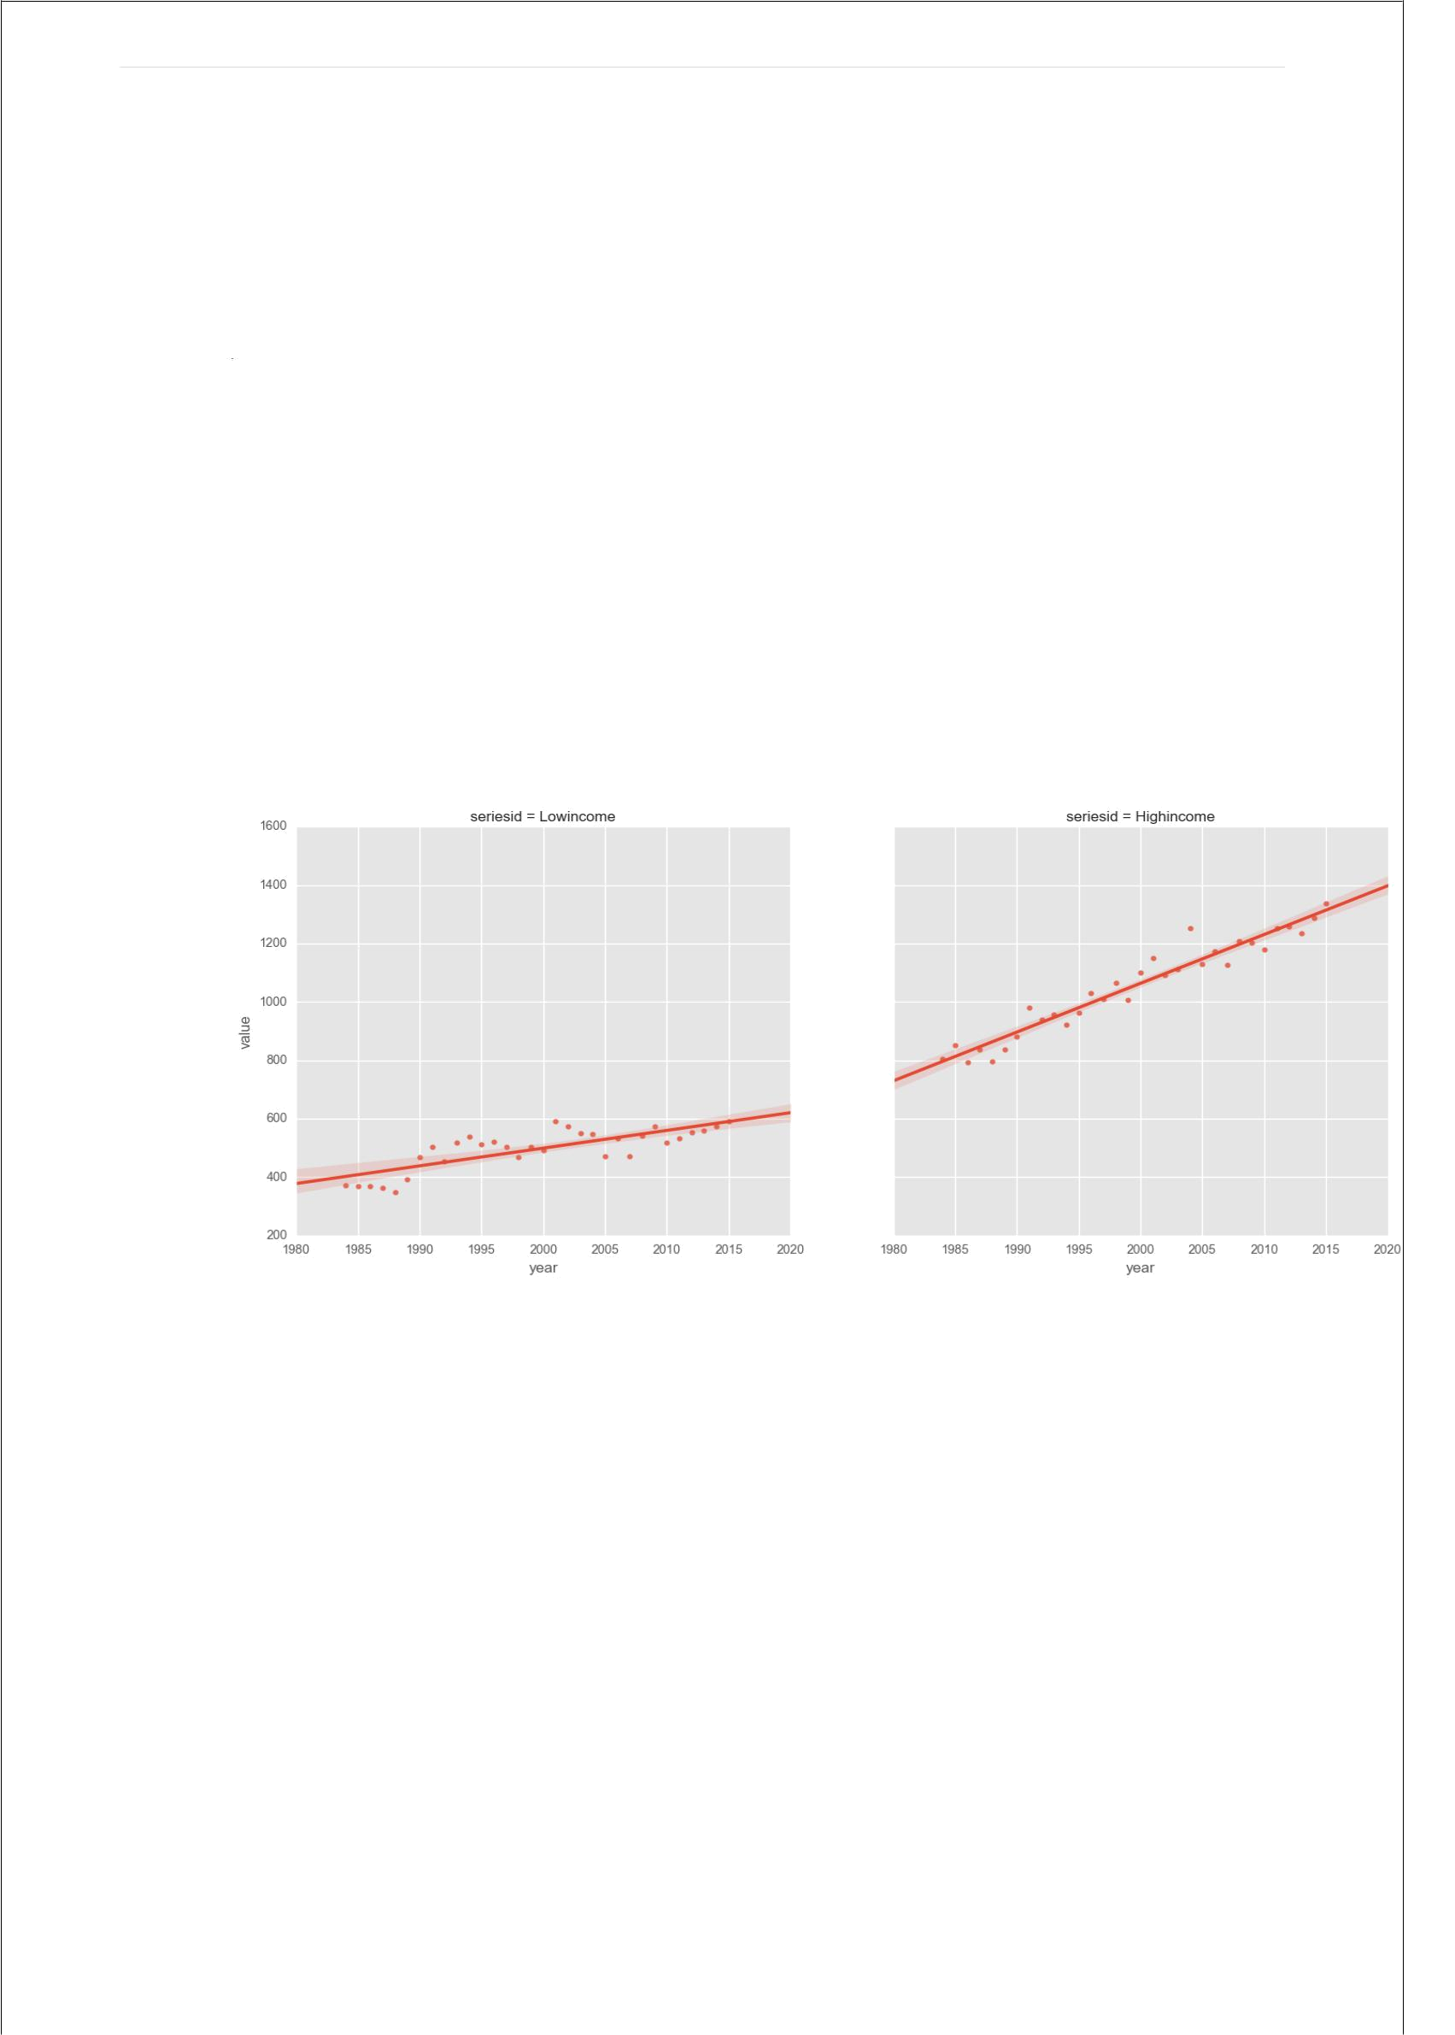
8 | P a g e

5. Correlation and Comparison:

Comparison and correlation based on income ,age ,area, race for food,housing,apparel,transportation,healthcare,apparel,entertainment,education.

5.1. Income based food (mpfe)

The first step we took in analysing the dataset was to find how different demographic categories spent on one of the categories of expenditure .i.e. food. From food we looked at expenses on meat, poultry, fish and eggs. Below are the visualization and python code for working with dataframes that hold these categories.

Fig 1. Highincome vs Lowincome Spending on Meat,Poultry,Fish and Eggs

Figure Description:

Figure 1 has the years on x-axis and average spending per year on y-axis. It illustrates the spending power for lowest 20% income people and highest 20% income people differed over the past 30 years. An interesting deduction from the graph is that where the value for lowincome ends with fitted line for next 5 years till 2020 , spending for high income people start from that point showing the consumer expenditure difference with change in income of a person.

Code Snippet :

#Replacing series_id’s with Demographic categories in dataframe imported as csv and saving in a new dataframe replaced1

replaced1=dataframe1.replace(['CXUANIMALLB0102M ','CXUANIMALLB0106M ','CXUANIMALLB0402M ','CXUANIMALLB0403M ','CXUANIMALLB0404M ','CXUANIMALLB0405M ','CXUANIMALLB0406M ','CXUANIMALLB0407M ','CXUANIMALLB0806M ','CXUANIMALLB0809M ','CXUANIMALLB0902M ','CXUANIMALLB0905M ','CXUANIMALLB01002M '],['Lowincome','Highincome','age<25','age25-35','age35-45','age45-55','age55-65','age>65','urban','rural','white/asian','black','hispanic'])

Lowincomempfe=replaced1['seriesid']=="Lowincome"
9 | P a g e

Lowincomempfe2=replaced1['year']<2016

Lowincomempfe3=replaced1[Lowincomempfe & Lowincomempfe2]

Highincomempfe=replaced1['seriesid']=="Highincome"

Highincomempfe2=replaced1['year']<2016

Highincomempfe3=replaced1[Highincomempfe & Highincomempfe2]
Highincomempfe3.corrwith(Lowincomempfe3,axis=0,drop=False) #Highincomempfe3.merge(Lowincomempfe3, left_on='seriesid', right_on='year', how='outer')

mpfeincomeframe=[Lowincomempfe3,Highincomempfe3]

resultincomempfe=pd.concat(mpfeincomeframe)
plt.plot(resultincomempfe['year'],resultincomempfe['value'])

plt.bar(resultincomempfe['year'],resultincomempfe['value'])

g=sns.FacetGrid(resultincomempfe,col='seriesid')

plt.title('Comparison of meat,poultry,fish,eggs spending by income groups') g.map(sns.regplot,"year","value")

plt.show()

5.2.Comparing Age Based on Food(MPFE)

The spending on different age group on purchasing food was compared. The age is divided into:

- below 25

- aged 25-35

- aged 35-45

- 45-55,

- 55-65

- above 65

A scatter plot was drawn to infer the spending status. The plot is shown below:

Fig 2. Spending by different age groups over 30 years

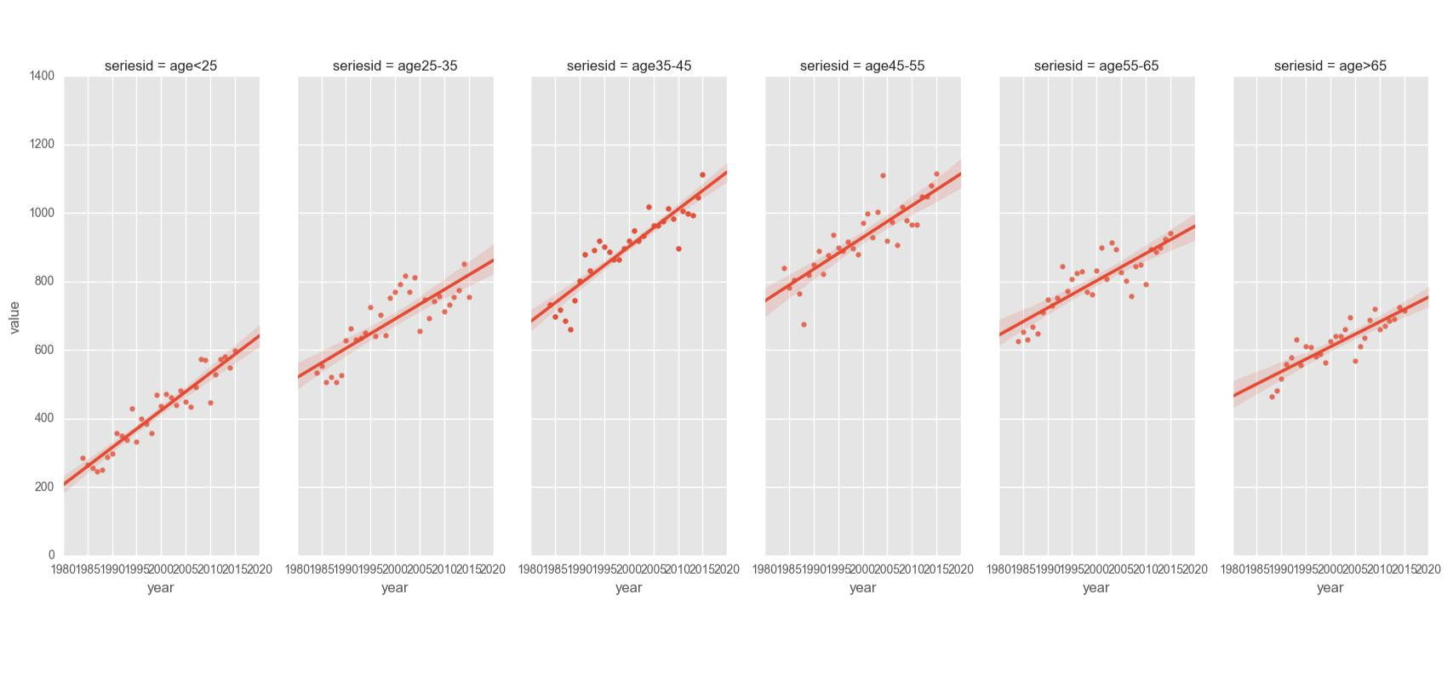

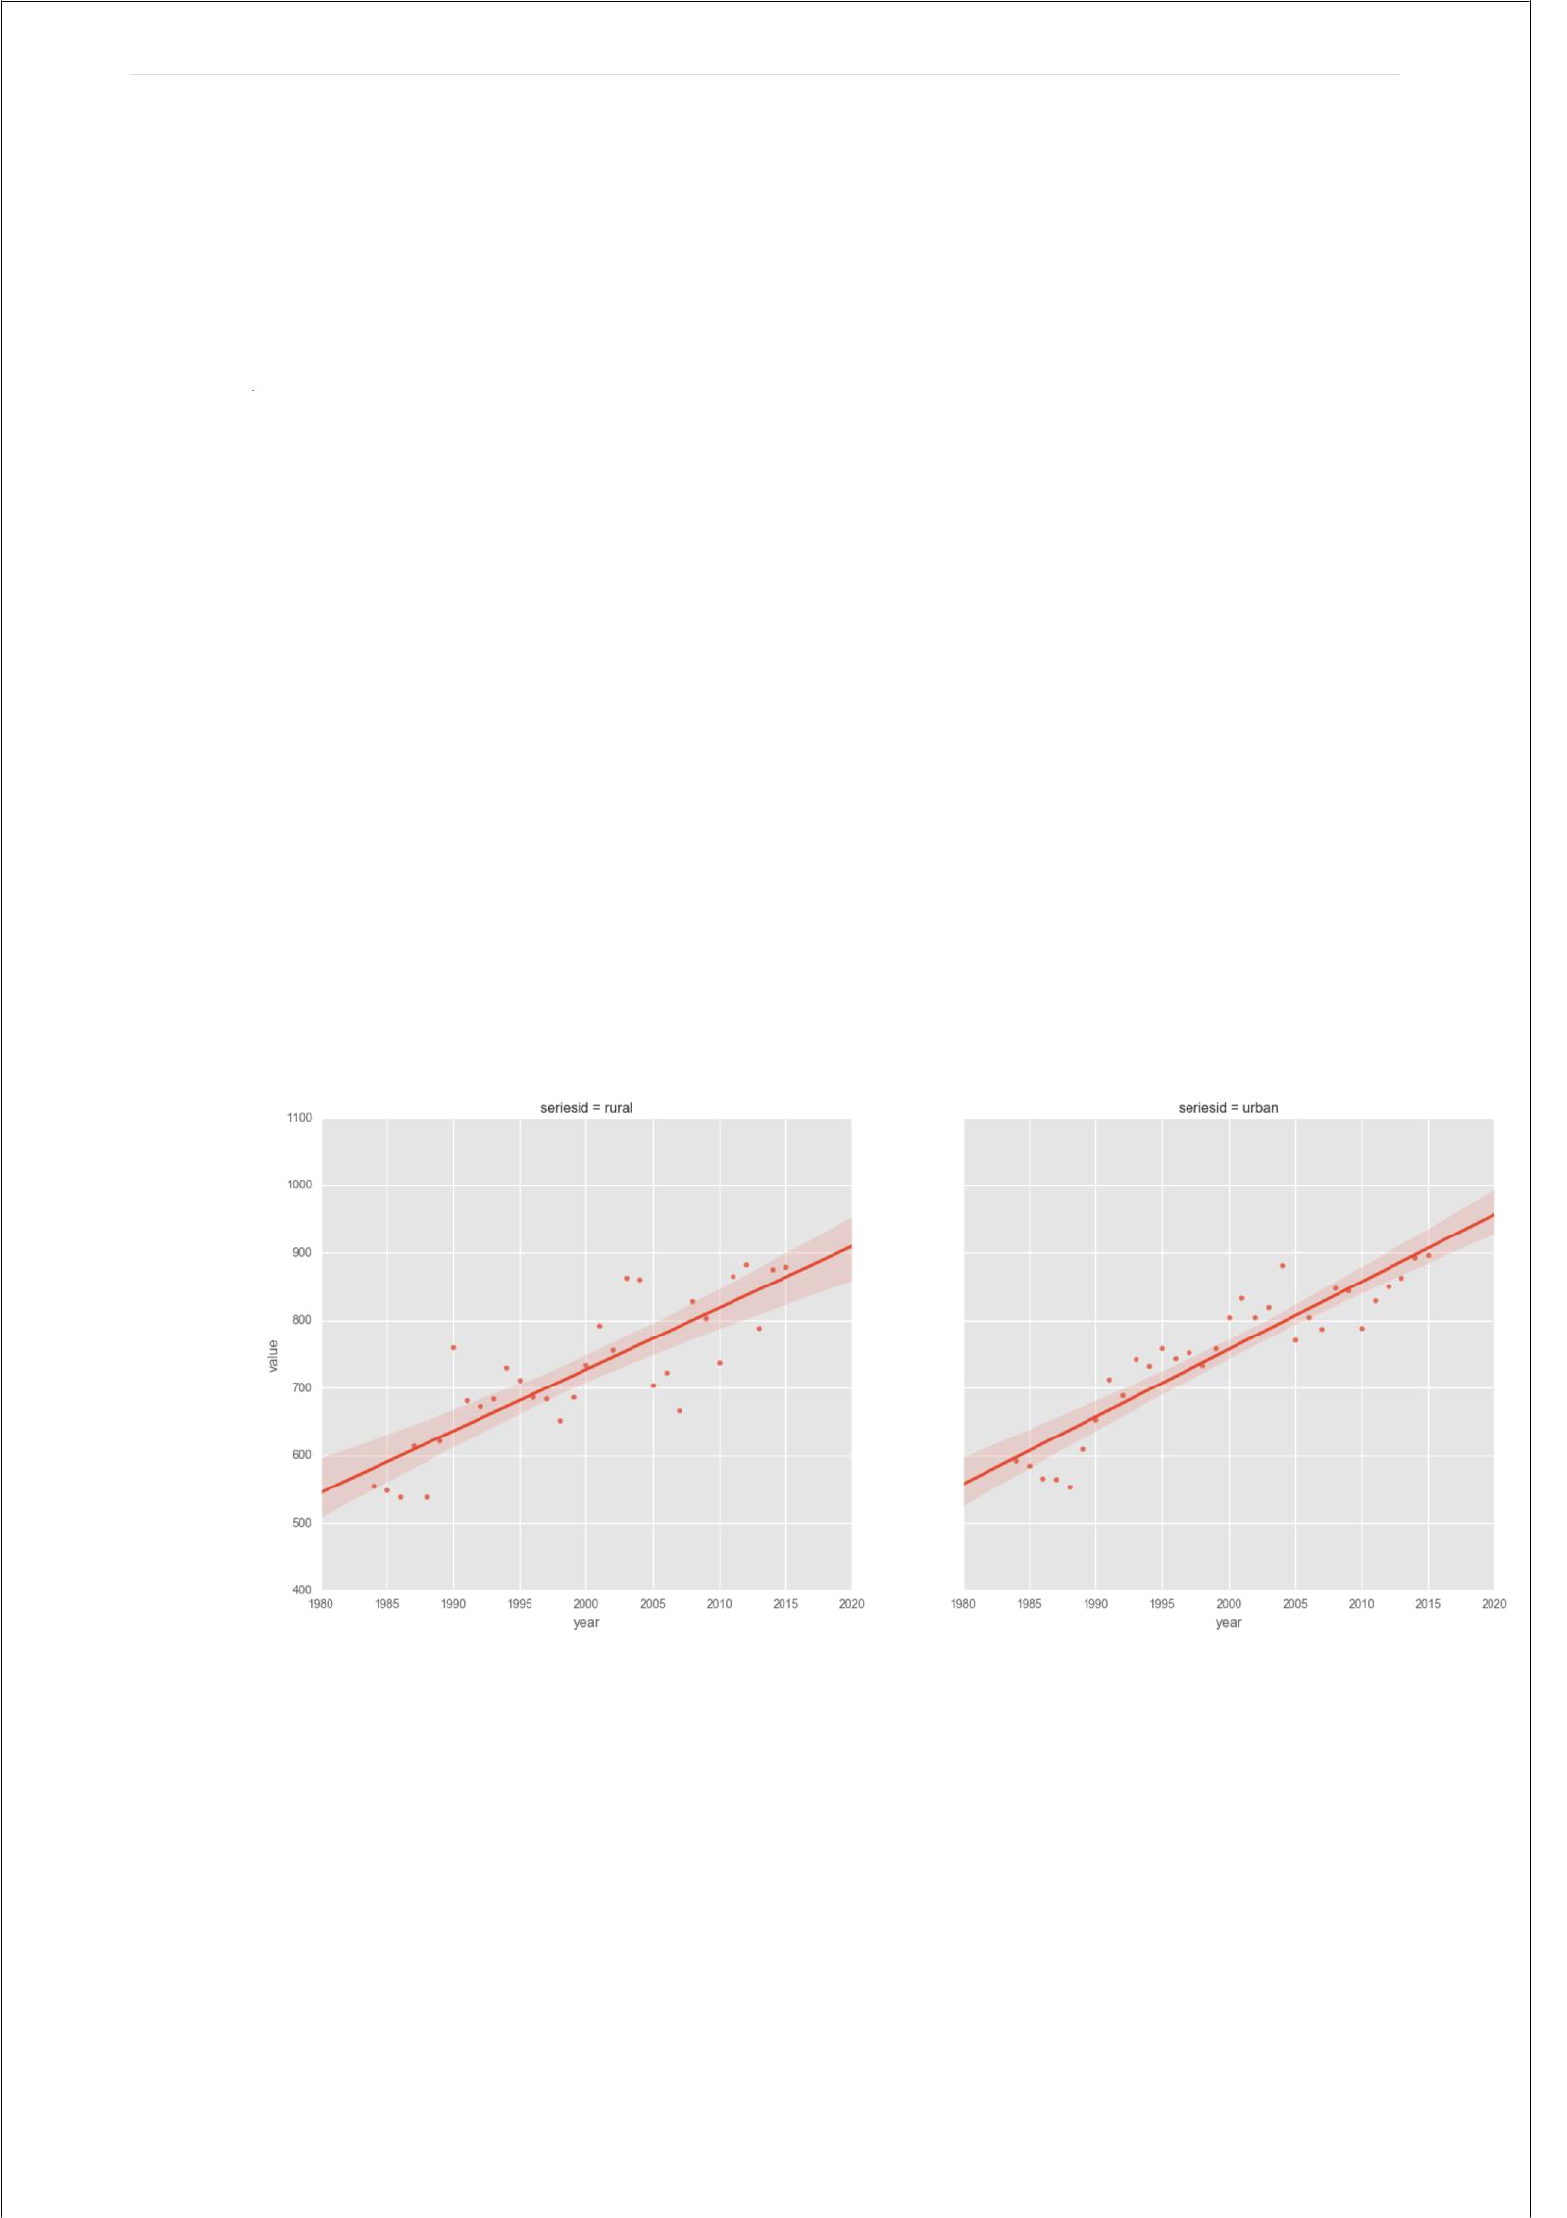
10 | P a g e

Conclusion:

Figure 2 depicts the spending based on different age groups. Age groups are shown on top of each graph and from viewing these it are evident that highest spending groups were people aged 35-45 and 45-55, followed closely by people aged 25-35 and 55-65 while people above 65 spent less and people below 25 spent the least.

5.3. Area based food (mpfe)

The consumer spending based on the location is classified. The location is classified as:

- Urban

- Rural

Figure 3 shows the spending by people living in different areas urban or rural.

Fig 3. Spending based on areas (rural/urban)

Conclusion:

It is almost same trend over the years but for different years it can be seen that in some years rural and in others urban spent more than each other e.g. in year 1990 rural spending was higher than urban spending on meat poultry and feed.
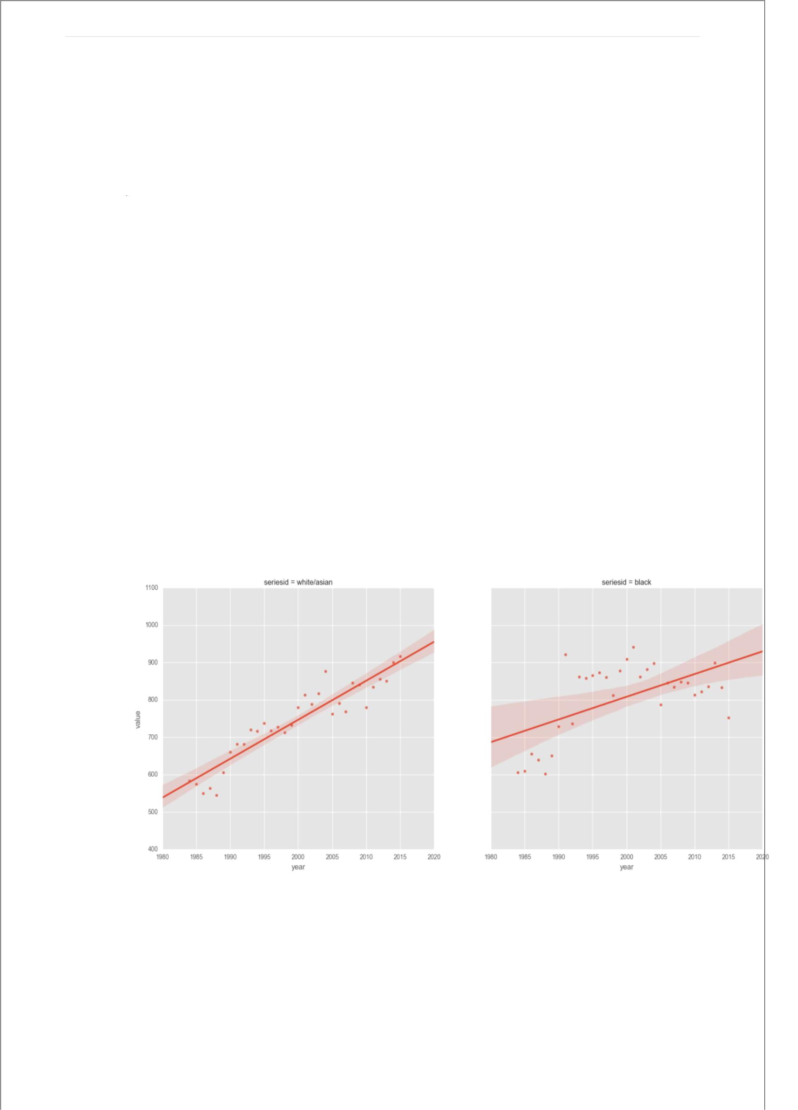
11 | P a g e

From analysis until now it has also become apparent that just plotting the values for spending for different years is not enough and we need a stronger measure such as percentage change between different years to clearly measure how the values increase/decrease over the years.

CodeSnippet:

c=replaced1['year']<2016

areampfe=replaced1['seriesid']=="urban" area1mpfe=replaced1[areampfe & c]

areampfe2=replaced1['seriesid']=="rural" area1mpfe2=replaced1[areampfe2 & c] mpfeareaframe=[area1mpfe2,area1mpfe] resultareampfe=pd.concat(mpfeareaframe)

g=sns.FacetGrid(resultareampfe,col='seriesid')

plt.title('Comparison of meat,poultry,fish,eggs spending by area groups') g.map(sns.regplot,"year","value")

plt.show()

5.4. Race based food (mpfe)

Spending of consumers based on race is inferred from data. Figure 4 shows spending by

white/Asian people and black people

Fig 4. Spending by racial groups

Conclusion:

Figure 4 shows spending by white/Asian people and black people. Black people spending are highly variable over the years and do not follow an almost linear line like for white/Asian people. Spending is highly inconsistent for black people and for the years 1990-2005 has increased after falling

12 | P a g e

significantly for next 10 years. It is therefore clear that demand cannot be measured accurately for black racial group as it is for white group for meat, poultry, fish and eggs.

Code Snippet :

c=replaced1['year']<2016

whitempfe=replaced1['seriesid']=="white/asian" white1mpfe=replaced1[whitempfe & c]
blackmpfe2=replaced1['seriesid']=="black" black1mpfe2=replaced1[blackmpfe2 & c]

hispanicmpfe2=replaced1['seriesid']=="hispanic" hispanic1mpfe2=replaced1[hispanicmpfe2 & c]

mpferaceframe=[white1mpfe,black1mpfe2,hispanic1mpfe2]

resultracempfe=pd.concat(mpferaceframe)

g=sns.FacetGrid(resultracempfe,col='seriesid')

plt.title('Comparison of meat,poultry,fish,eggs spending by racial groups') g.map(sns.regplot,"year","value")

plt.show()

Pie chart (categories consumption of total)

Fig 5 . Pie chart for MPFE spending for year 2015

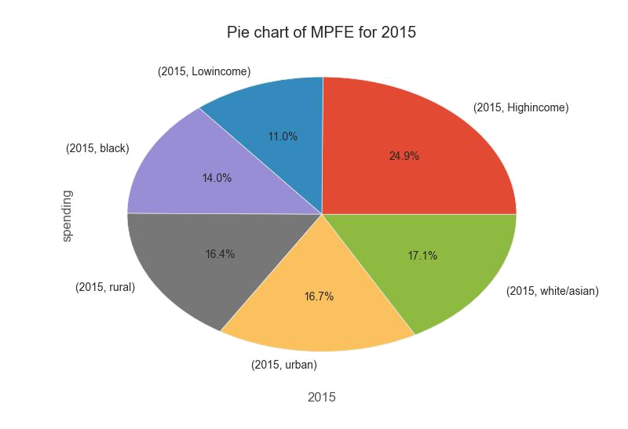

13 | P a g e

Pie chart explanation /Conclusion :

Figure 5. shows the relative spending by different demographics for year 2015. Income is the most prominent feature in determining the average consumer expenditure for a year as it has highest overall share of total.

Code:

sframe=newmpfeframe1.stack()

# plot chart

sframe.plot(kind='pie' , autopct='%1.1f%%', subplots=True) plt.title('Pie chart of MPFE for 2015')

plt.xlabel('2015')

plt.ylabel('spending')

fig = plt.figure(figsize=(6,6), dpi=100)

.

6. Predictions:

6.1. Foods

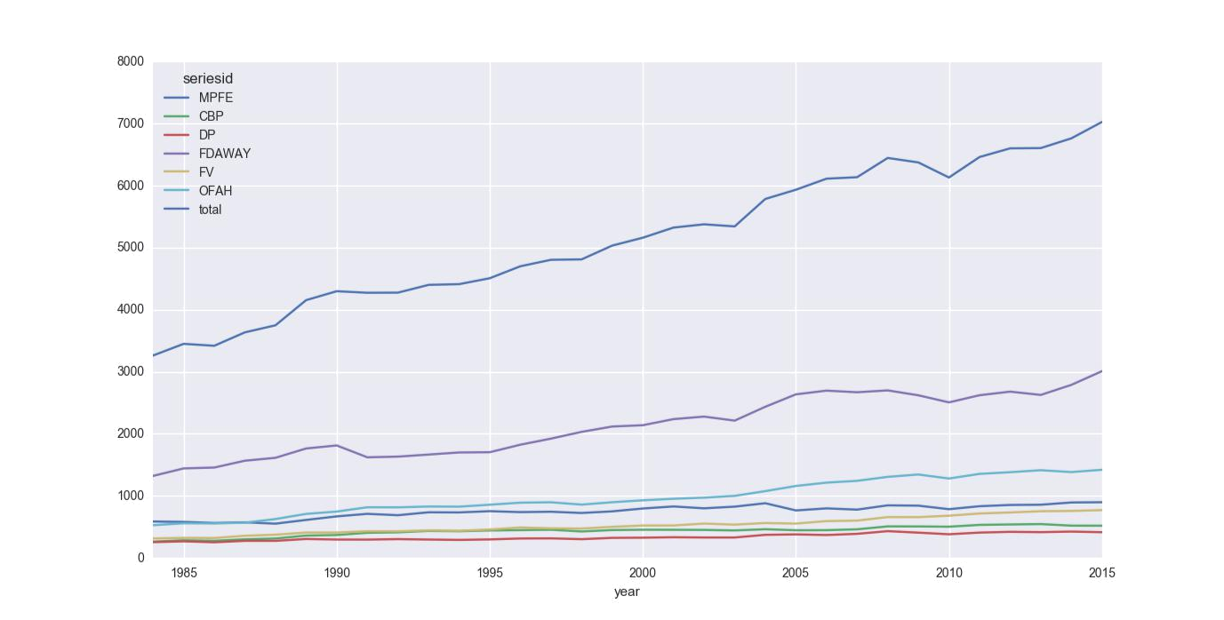

Fig 6.1. Overall annual expenditure by different categories of food

14 | P a g e

Explanation :

Figure 6 is showing the overall spending for different categories in food for past 30 years. The keys indicated with graph are:

- MPFE =meat, poultry, fish and eggs

- CBP=cereals and bakery products

- DP=Dairy Products

- FDAWAY=Food consumed on outside trips

- FV=Fruits and Vegetables

- OFAH=Other Foods at home

A cumulative spending increased over the years but for most of the categories followed a straight line. Perhaps the highest increase seen is in foods away from home and other foods at home. Overall average expenditure has on food annually has grown from 3200 in 1984 to 7000 in 2015.

Code snippet:

data2=dataframe1.replace(['CXUANIMALLB0101M ','CXUCERBAKRYLB0101M ','CXUDAIRYLB0101M ','CXUFOODAWAYLB0101M ','CXUFRUITVEGLB0101M ','CXUOTHRFOODLB0101M '],['MPFE','CBP','DP','FDAWAY','FV','OFAH'])

a=data2['year']<2020

mpfe1=data2['seriesid']=='MPFE' mpfe2=data2[mpfe1 & a]

cbp=data2['seriesid']=='CBP'

cbp2=data2[cbp&a]

dp=data2['seriesid']=='DP'

dp2=data2[dp&a]

fdaway=data2['seriesid']=='FDAWAY'

fdaway2=data2[fdaway&a]

fv=data2['seriesid']=='FV'

fv2=data2[fv&a]

ofah=data2['seriesid']=='OFAH'

ofah2=data2[ofah&a]
mainframefood=[mpfe2,cbp2,dp2,fdaway2,fv2,ofah2]

finalfood=pd.concat(mainframefood)

#print(finalfood)

finalfood.describe()

newfoods=finalfood.pivot(index='year', columns='seriesid', values='value') #print(newfoods)

#create a new column in newfoods dataframe called total and save the sum of all column values in that. This column represents total average consumer annual expenditure

#on food and what we will be using to predict future expenditure newfoods['total']=newfoods.sum(axis=1)

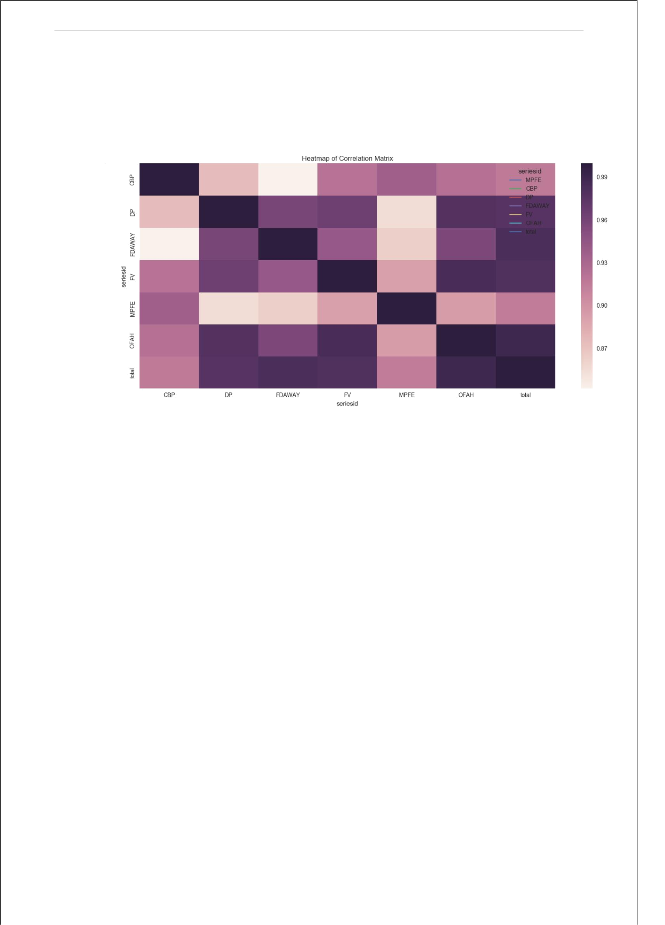
15 | P a g e

Fig 6.2. Correlation between different food categories

Explanation:

In figure 6.2 correlations between spending on different food categories over the years is visualized. It is shown that some food categories correlate to each other more than others. OFAH, FDAWAY, FV, DP correlate strongly to total spending. Other correlations with each other are also shown in this heatmap.

Table 1 below has the values over 30 years for food categories as well as total percentage change has been added to clearly show how values changed (rose/fell).

Year | CBP | DP | FDAWAY | FV | MPFE | OFAH | Total | %Change
1984 | 262 | 253 | 1320 | 313 | 586 | 526 | 3260 | nan
1985 | 283 | 266 | 1441 | 322 | 579 | 557 | 3448 | 0.057669
1986 | 275 | 251 | 1455 | 320 | 562 | 554 | 3417 | -0.00899
1987 | 299 | 274 | 1565 | 356 | 572 | 567 | 3633 | 0.063213
1988 | 312 | 274 | 1612 | 373 | 551 | 625 | 3747 | 0.031379
1989 | 359 | 304 | 1762 | 408 | 611 | 708 | 4152 | 0.108086
1990 | 368 | 295 | 1811 | 408 | 668 | 746 | 4296 | 0.034682
1991 | 404 | 294 | 1620 | 429 | 709 | 815 | 4271 | -0.00582
16 | P a g e

1992 | 411 | 302 | 1631 | 428 | 687 | 814 | 4273 | 0.000468
1993 | 434 | 295 | 1664 | 444 | 734 | 827 | 4398 | 0.029253
1994 | 429 | 289 | 1698 | 437 | 732 | 825 | 4410 | 0.002729
1995 | 441 | 297 | 1702 | 457 | 752 | 856 | 4505 | 0.021542
1996 | 447 | 312 | 1823 | 490 | 737 | 889 | 4698 | 0.042841
1997 | 453 | 314 | 1921 | 476 | 743 | 895 | 4802 | 0.022137
1998 | 425 | 301 | 2030 | 472 | 723 | 858 | 4809 | 0.001458
1999 | 448 | 322 | 2116 | 500 | 749 | 896 | 5031 | 0.046163
2000 | 453 | 325 | 2137 | 521 | 795 | 927 | 5158 | 0.025243
2001 | 452 | 332 | 2235 | 522 | 828 | 952 | 5321 | 0.031601
2002 | 450 | 328 | 2276 | 552 | 798 | 970 | 5374 | 0.009961
2003 | 442 | 328 | 2211 | 535 | 825 | 999 | 5340 | -0.00633
2004 | 461 | 371 | 2434 | 561 | 880 | 1075 | 5782 | 0.082772
2005 | 445 | 378 | 2634 | 552 | 764 | 1158 | 5931 | 0.02577
2006 | 446 | 368 | 2694 | 592 | 797 | 1212 | 6109 | 0.030012
2007 | 460 | 387 | 2668 | 600 | 777 | 1241 | 6133 | 0.003929
2008 | 507 | 430 | 2698 | 657 | 846 | 1305 | 6443 | 0.050546
2009 | 506 | 406 | 2619 | 656 | 841 | 1343 | 6371 | -0.01117
2010 | 502 | 380 | 2505 | 679 | 784 | 1278 | 6128 | -0.03814
2011 | 531 | 407 | 2620 | 715 | 832 | 1353 | 6458 | 0.053851
2012 | 538 | 419 | 2678 | 731 | 852 | 1380 | 6598 | 0.021679
2013 | 544 | 414 | 2625 | 751 | 856 | 1412 | 6602 | 0.000606
2014 | 519 | 423 | 2787 | 756 | 892 | 1382 | 6759 | 0.023781
2015 | 518 | 413 | 3008 | 769 | 896 | 1419 | 7023 | 0.039059

Fig 6.3 Percentage change in food spending

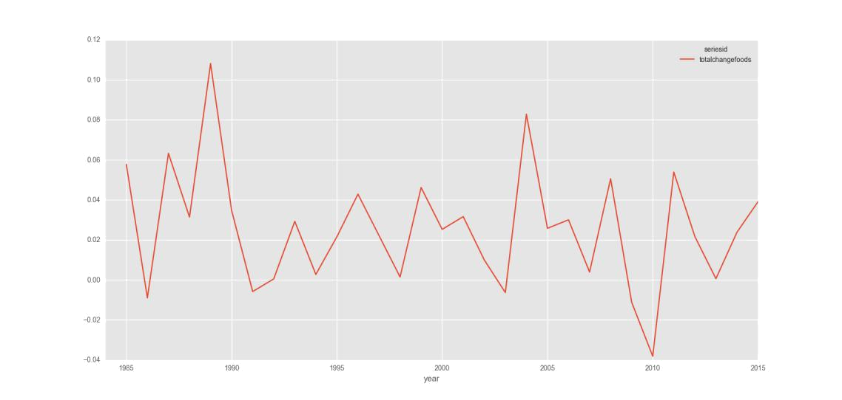

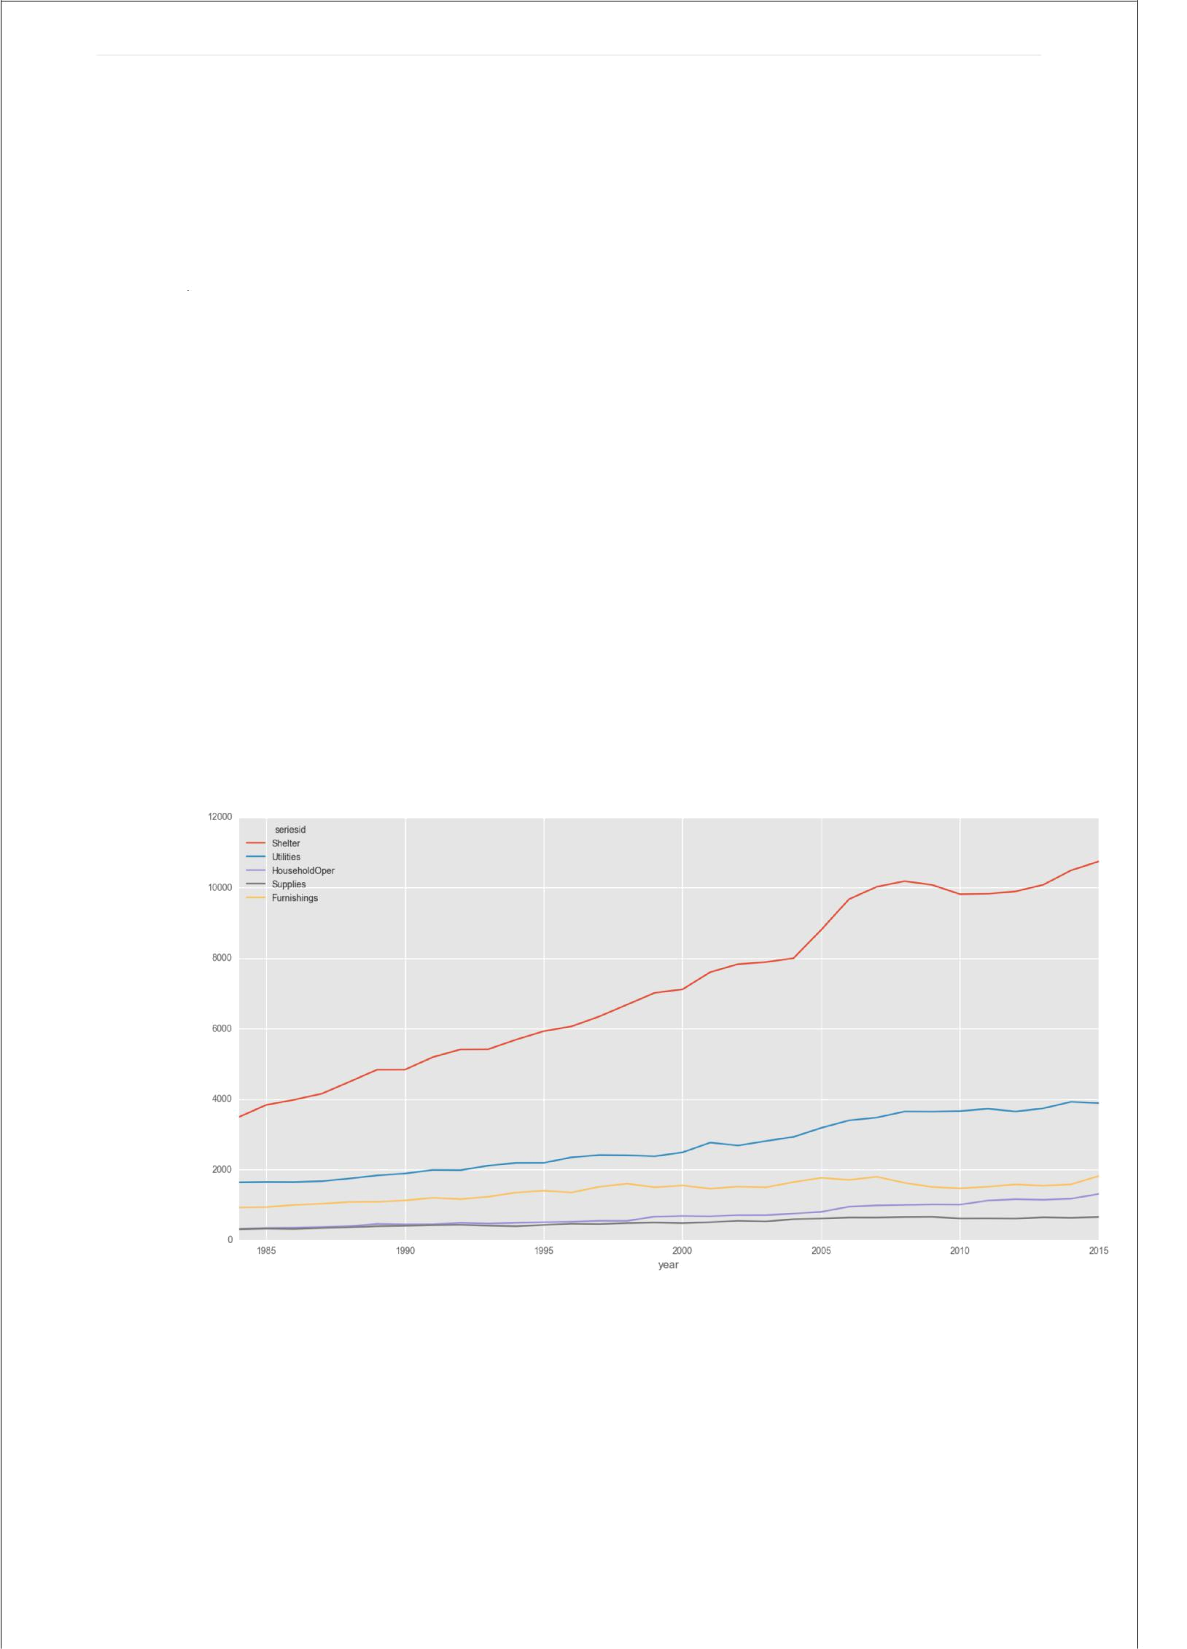
17 | P a g e

Figure Explanation:

Figure 6.3 is depicting the increase and decrease in spending on food more intuitively by plotting percentage values over 30 years. Sharp rises and falls can be clearly seen. There is a sharp decline around 2008 which is indicative of the economic crisis at that point of time.

6.2.House:

Figure 7.1 is showing the spending on housing which includes shelter, utilities, household operations, supplies and furnishings. Spending on utilities such as water and electricity has more than doubled. For household supplies it has remained static and for furnishings it decreased rapidly after 2006 and remained at one point before rising around 2014. For spending on shelter i.e. houses, apartments it increased linearly before a big jump around 2004 and increased till 2008 before falling around 2008 and then rising back after 2013.

Fig 7.1 Spending on Housing

Code Snippet :

#Storing in new dataframes values for all the subcategories and merging with year<2016 Shelter1=datahousing[‘seriesid’]==’Shelter’

Shelter2=datahousing[Shelter1 & a]

Utilities1=datahousing[‘seriesid’]==’Utilities’

Utilities2=datahousing[Utilities1 & a]

Houseoperations1=datahousing[‘seriesid’]==’HouseholdOper’

Houseoperations2=datahousing[Houseoperations1 & a]
18 | P a g e

Supplies1=datahousing[‘seriesid’]==’Supplies’
Supplies2=datahousing[Supplies1 & a]

Furnishings1=datahousing[‘seriesid’]==’Furnishings’
Furnishings2=datahousing[Furnishings1 & a]

#mainframehouse has all the dataframes for house category and finalhouse 18onstitutes all dataframes concatenated mainframehouse=[Shelter2,Utilities2,Houseoperations2,Supplies2,Furnishings2] finalhouse=pd.concat(mainframehouse)
#newhouse dataframe has index replaced with year and columns represented as series_id’s through pivot function

newhouse=finalhouse.pivot(index=’year’, columns=’seriesid’, values=’value’) newhouse[[‘Shelter’,’Utilities’,’HouseholdOper’,’Supplies’,’Furnishings’]].plot(kind=’line’, use_index=True)

newhouse[‘totalhouse’]=newhouse.sum(axis=1) newhouse[‘totalchangehouse’]=newhouse[‘totalhouse’].pct_change()

Table below describes the spending :

Year | Furnishing | HouseOpe | Shelte | Supplie | Utilitie | Tota | %Chang
 | s | r | r | s | s | l | e
198
4 | 926 | 315 | 3489 | 307 | 1638 | 6675
198
5 | 936 | 346 | 3833 | 325 | 1648 | 7088 | 0.061873
198
6 | 998 | 354 | 3979 | 316 | 1645 | 7292 | 0.028781
198
7 | 1032 | 371 | 4154 | 341 | 1671 | 7569 | 0.037987
198
8 | 1083 | 394 | 4493 | 361 | 1747 | 8078 | 0.067248
198
9 | 1086 | 460 | 4835 | 394 | 1835 | 8610 | 0.065858
199
0 | 1125 | 446 | 4836 | 406 | 1890 | 8703 | 0.010801
199
1 | 1200 | 448 | 5191 | 424 | 1990 | 9253 | 0.063197
199
2 | 1162 | 487 | 5411 | 433 | 1984 | 9477 | 0.024208
199
3 | 1230 | 469 | 5415 | 410 | 2112 | 9636 | 0.016777
199
4 | 1348 | 490 | 5686 | 393 | 2189 | 10106 | 0.048775
199
5 | 1401 | 509 | 5928 | 430 | 2191 | 10459 | 0.03493

19 | P a g e

199
6 | 1350 | 522 | 6064 | 464 | 2347 | 10747 | 0.027536
199
7 | 1512 | 548 | 6344 | 455 | 2412 | 11271 | 0.048758
199
8 | 1601 | 546 | 6680 | 482 | 2405 | 11714 | 0.039304
199
9 | 1499 | 666 | 7016 | 498 | 2377 | 12056 | 0.029196
200
0 | 1549 | 684 | 7114 | 482 | 2489 | 12318 | 0.021732
200
1 | 1458 | 676 | 7602 | 509 | 2767 | 13012 | 0.05634
200
2 | 1518 | 706 | 7829 | 545 | 2684 | 13282 | 0.02075
200
3 | 1497 | 707 | 7887 | 529 | 2811 | 13431 | 0.011218
200
4 | 1646 | 753 | 7998 | 594 | 2927 | 13918 | 0.036259
200
5 | 1767 | 801 | 8805 | 611 | 3183 | 15167 | 0.08974
200
6 | 1708 | 948 | 9673 | 640 | 3397 | 16366 | 0.079053
200
7 | 1797 | 984 | 10023 | 639 | 3477 | 16920 | 0.033851
200
8 | 1624 | 998 | 10183 | 654 | 3649 | 17108 | 0.011111
200
9 | 1506 | 1011 | 10075 | 659 | 3645 | 16896 | -0.01239
201
0 | 1467 | 1007 | 9812 | 612 | 3660 | 16558 | -0.02
201
1 | 1514 | 1122 | 9825 | 615 | 3727 | 16803 | 0.014796
201
2 | 1580 | 1159 | 9891 | 610 | 3648 | 16888 | 0.005059
201
3 | 1542 | 1144 | 10080 | 645 | 3737 | 17148 | 0.015396
201
4 | 1581 | 1174 | 10491 | 632 | 3921 | 17799 | 0.037964
201
5 | 1818 | 1309 | 10742 | 655 | 3885 | 18409 | 0.034272

20 | P a g e

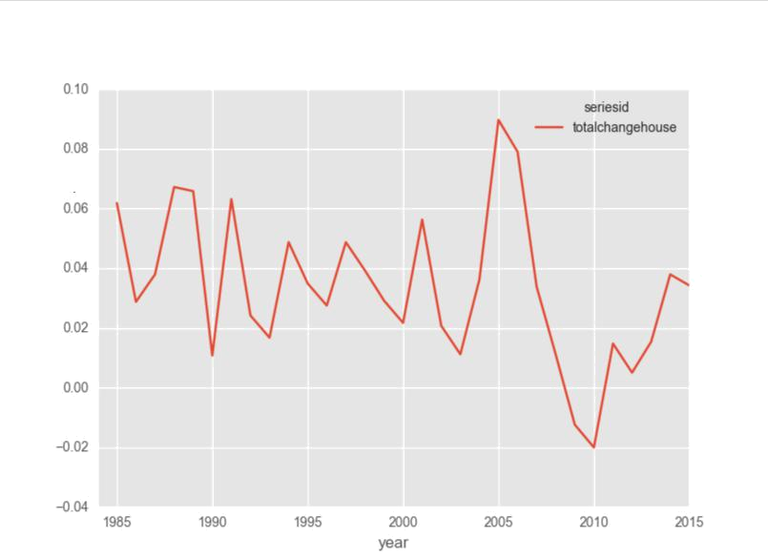

Fig 7.2 Total percentage change in housing expenditure

Explanation:

Figure 7.2 shows the total percentage change on housing which shows how housing market has evolved over time. People have spent increasingly/decreasingly for consistent 2-3 years before it changes again but percentage change has still remained positive until 2008 when it has gone negative before revering in 2010 and rising steadily to current value.

Fig 7.3 Subplots of total % change in food and housing

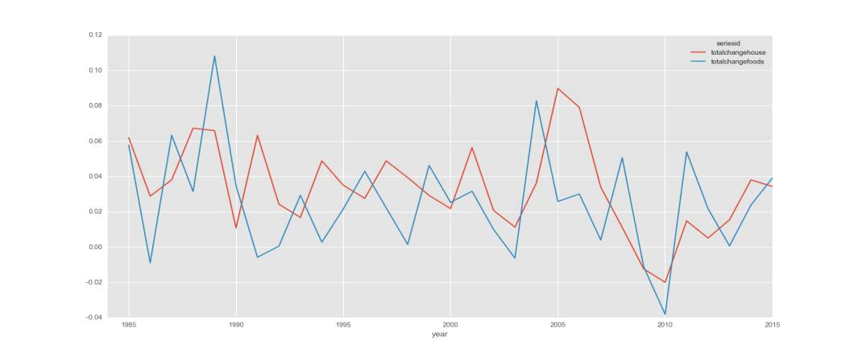

21 | P a g e

Figure 7.3 shows the graphs for housing and foods side by side but to get a clearer idea of how spending on both correlated over the years we have plotted correlation of both in figure 7.4 below.

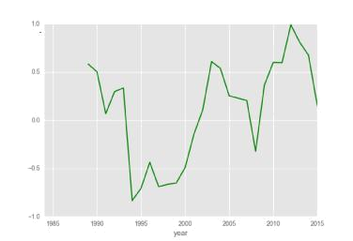

Fig 7.4 Correlation between housing/food spending

The housing and food expenditure remained negatively correlated from 1993 to 2002. Afterwards the correlation is mostly positive with complete correlation of 1.0 in 2012 meaning if people spent on housing they also spent on food.

ax1=newhouse[['totalchangehouse']].plot(kind='line', use_index=True)

newfoods[['totalchangefoods']].plot(kind='line', use_index=True,ax=ax1)

pd.rolling_corr(newhouse['totalchangehouse'], newfoods['totalchangefoods'], window=5).plot(style='-g')

22 | P a g e

6.3. Healthcare/Education/Entertainment/Apparel

Spending for 4 different expenditure categories is shown which shows that spending on healthcare increased significantly(almost exponentially).The second highest is Apparel. Followed by Education and Entertainment

Fig 8 Healthcare, Education, Apparel, Entertainment Spending

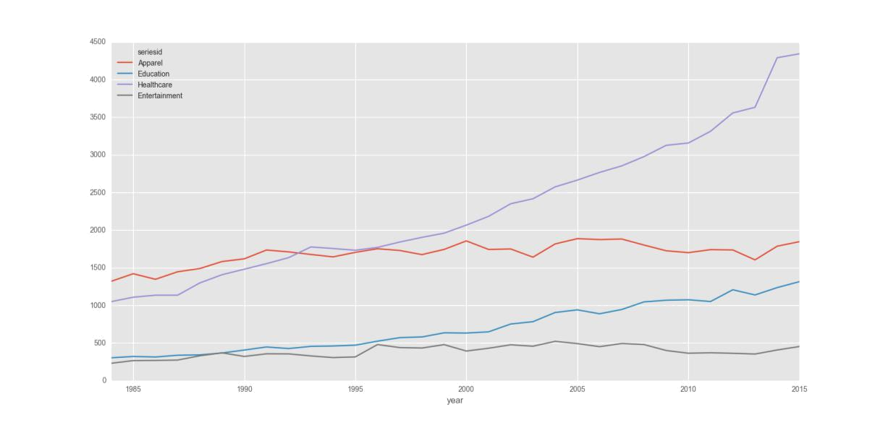

In figure 8.1 spending for 4 different expenditure categories is shown which shows that spending on healthcare increased significantly(almost exponentially).

Year | Apparel | Education | Entertainment | Healthcare | Total | %Change
1984 | 1319 | 303 | 230 | 1049 | 2901
1985 | 1420 | 321 | 266 | 1108 | 3115 | 0.073768
1986 | 1346 | 314 | 268 | 1135 | 3063 | -0.01669
1987 | 1446 | 337 | 273 | 1135 | 3191 | 0.041789
1988 | 1489 | 342 | 330 | 1298 | 3459 | 0.083986
1989 | 1582 | 367 | 369 | 1407 | 3725 | 0.076901
1990 | 1618 | 406 | 321 | 1480 | 3825 | 0.026846
1991 | 1735 | 447 | 356 | 1554 | 4092 | 0.069804
1992 | 1710 | 426 | 355 | 1634 | 4125 | 0.008065
1993 | 1676 | 455 | 328 | 1776 | 4235 | 0.026667
1994 | 1644 | 460 | 306 | 1755 | 4165 | -0.01653
1995 | 1704 | 471 | 315 | 1732 | 4222 | 0.013685
1996 | 1752 | 524 | 479 | 1770 | 4525 | 0.071767
1997 | 1729 | 571 | 439 | 1841 | 4580 | 0.012155

23 | P a g e

1998 | 1674 | 580 | 433 | 1903 | 4590 | 0.002183
1999 | 1743 | 635 | 478 | 1959 | 4815 | 0.04902
2000 | 1856 | 632 | 393 | 2066 | 4947 | 0.027414
2001 | 1743 | 648 | 430 | 2182 | 5003 | 0.01132
2002 | 1749 | 752 | 476 | 2350 | 5327 | 0.064761
2003 | 1640 | 783 | 457 | 2416 | 5296 | -0.00582
2004 | 1816 | 905 | 522 | 2574 | 5817 | 0.098376
2005 | 1886 | 940 | 492 | 2664 | 5982 | 0.028365
2006 | 1874 | 888 | 451 | 2766 | 5979 | -0.0005
2007 | 1881 | 945 | 493 | 2853 | 6172 | 0.03228
2008 | 1801 | 1046 | 479 | 2976 | 6302 | 0.021063
2009 | 1725 | 1068 | 400 | 3126 | 6319 | 0.002698
2010 | 1700 | 1074 | 364 | 3157 | 6295 | -0.0038
2011 | 1740 | 1051 | 370 | 3313 | 6474 | 0.028435
2012 | 1736 | 1207 | 363 | 3556 | 6862 | 0.059932
2013 | 1604 | 1138 | 353 | 3631 | 6726 | -0.01982
2014 | 1786 | 1236 | 407 | 4290 | 7719 | 0.147636
2015 | 1846 | 1315 | 453 | 4342 | 7956 | 0.030703

6.4.Transport:

Spending on transportation is shown in figure 9 in which the trends are clear for Vehicle Purchase and Gasoline/Motor oil spending especially. Spending on gasoline started increasing rapidly around 1998. Vehicle purchase spending decreased after 2005 and again started increasing after 2011.

Fig 9.1 Spending on transportation

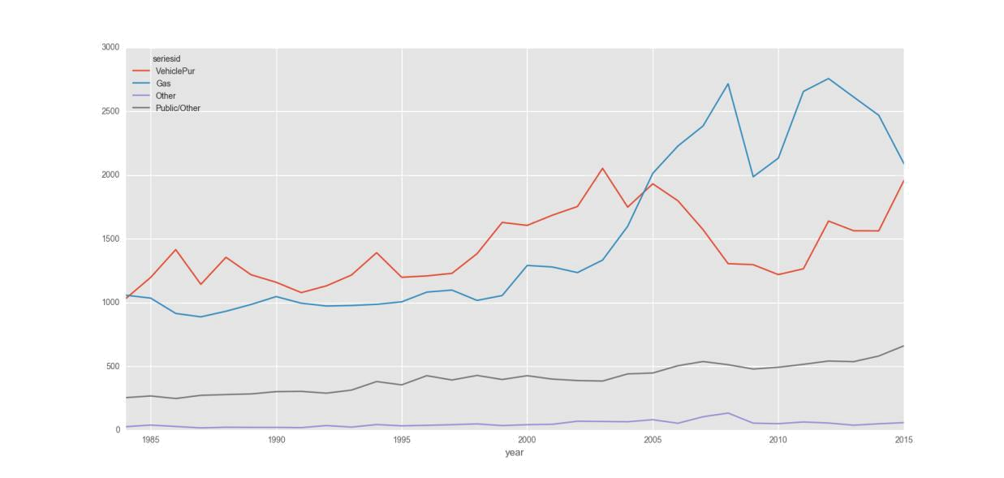

24 | P a g e

Year | Gas | Other | Public/Other | VehiclePur | Total | %Change
1984 | 1058 | 27 | 255 | 1030 | 2370
1985 | 1035 | 40 | 268 | 1197 | 2540 | 0.07173
1986 | 915 | 29 | 248 | 1415 | 2607 | 0.026378
1987 | 888 | 18 | 273 | 1143 | 2322 | -0.10932
1988 | 932 | 23 | 279 | 1355 | 2589 | 0.114987
1989 | 985 | 22 | 284 | 1218 | 2509 | -0.0309
1990 | 1047 | 22 | 302 | 1159 | 2530 | 0.00837
1991 | 995 | 20 | 304 | 1078 | 2397 | -0.05257
1992 | 973 | 36 | 290 | 1131 | 2430 | 0.013767
1993 | 977 | 24 | 314 | 1216 | 2531 | 0.041564
1994 | 986 | 44 | 381 | 1391 | 2802 | 0.107072
1995 | 1006 | 34 | 355 | 1198 | 2593 | -0.07459
1996 | 1082 | 38 | 427 | 1209 | 2756 | 0.062862
1997 | 1098 | 43 | 393 | 1229 | 2763 | 0.00254
1998 | 1017 | 49 | 429 | 1383 | 2878 | 0.041621
1999 | 1055 | 36 | 397 | 1628 | 3116 | 0.082696
2000 | 1291 | 43 | 427 | 1605 | 3366 | 0.080231
2001 | 1279 | 46 | 400 | 1685 | 3410 | 0.013072
2002 | 1235 | 70 | 389 | 1753 | 3447 | 0.01085
2003 | 1333 | 68 | 385 | 2052 | 3838 | 0.113432
2004 | 1598 | 66 | 441 | 1748 | 3853 | 0.003908
2005 | 2013 | 82 | 448 | 1931 | 4474 | 0.161173
2006 | 2227 | 54 | 505 | 1798 | 4584 | 0.024586
2007 | 2384 | 105 | 538 | 1572 | 4599 | 0.003272
2008 | 2715 | 134 | 513 | 1305 | 4667 | 0.014786
2009 | 1986 | 55 | 479 | 1297 | 3817 | -0.18213
2010 | 2132 | 51 | 493 | 1219 | 3895 | 0.020435
2011 | 2655 | 64 | 516 | 1265 | 4500 | 0.155327
2012 | 2756 | 56 | 542 | 1639 | 4993 | 0.109556
2013 | 2611 | 39 | 537 | 1563 | 4750 | -0.04867
2014 | 2468 | 50 | 581 | 1562 | 4661 | -0.01874
2015 | 2090 | 59 | 661 | 1956 | 4766 | 0.022527

Fig 9.2 Total change in transportation

25 | P a g e

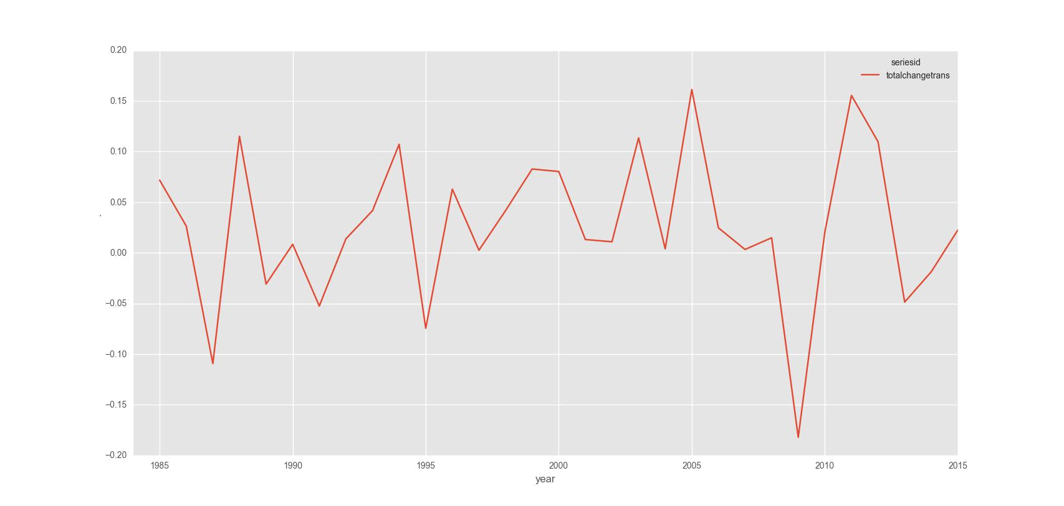

Fig 9.2 Total change in transportation

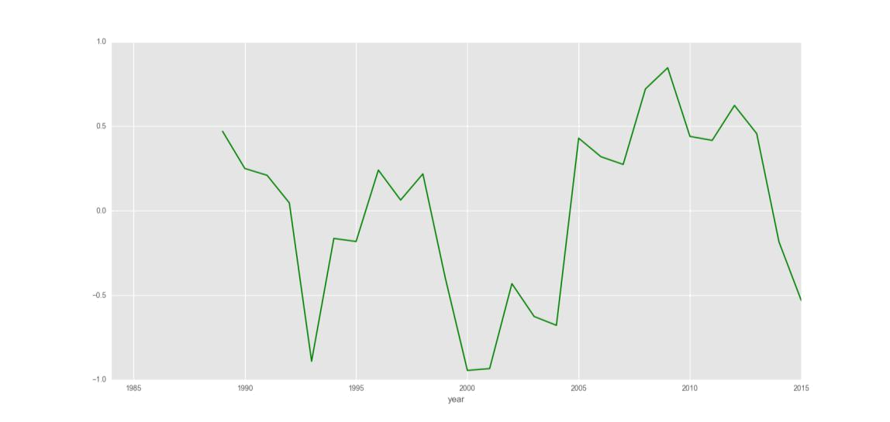

Fig 9.3 Housing vs transportation correlation

Average consumer expenditure

Year | Ave. | PCT- | Label
 | Consumer | Change
 | Expense
1984 | 15206 | -99999 | 0.011611
1985 | 16191 | 0.064777 | 0.020514
1986 | 16379 | 0.011611 | 0.069279
1987 | 16715 | 0.020514 | 0.062832
1988 | 17873 | 0.069279 | 0.018846

26 | P a g e

1989 | 18996 | 0.062832 | 0.03405
1990 | 19354 | 0.018846 | 0.014591
1991 | 20013 | 0.03405 | 0.024378
1992 | 20305 | 0.014591 | 0.032837
1993 | 20800 | 0.024378 | 0.013778
1994 | 21483 | 0.032837 | 0.043482
1995 | 21779 | 0.013778 | 0.030362
1996 | 22726 | 0.043482 | 0.024556
1997 | 23416 | 0.030362 | 0.042808
1998 | 23991 | 0.024556 | 0.030818
1999 | 25018 | 0.042808 | 0.037109
2000 | 25789 | 0.030818 | 0.025574
2001 | 26746 | 0.037109 | 0.017317
2002 | 27430 | 0.025574 | 0.0525
2003 | 27905 | 0.017317 | 0.074362
2004 | 29370 | 0.0525 | 0.04703
2005 | 31554 | 0.074362 | 0.023791
2006 | 33038 | 0.04703 | 0.020577
2007 | 33824 | 0.023791 | -0.03236
2008 | 34520 | 0.020577 | -0.01578
2009 | 33403 | -0.03236 | 0.041337
2010 | 32876 | -0.01578 | 0.032306
2011 | 34235 | 0.041337 | -0.00325
2012 | 35341 | 0.032306 | 0.0486
2013 | 35226 | -0.00325 | 0.03292
2014 | 15206 | -99999 | 0.011611
2015 | 16191 | 0.064777 | 0.020514

27 | P a g e
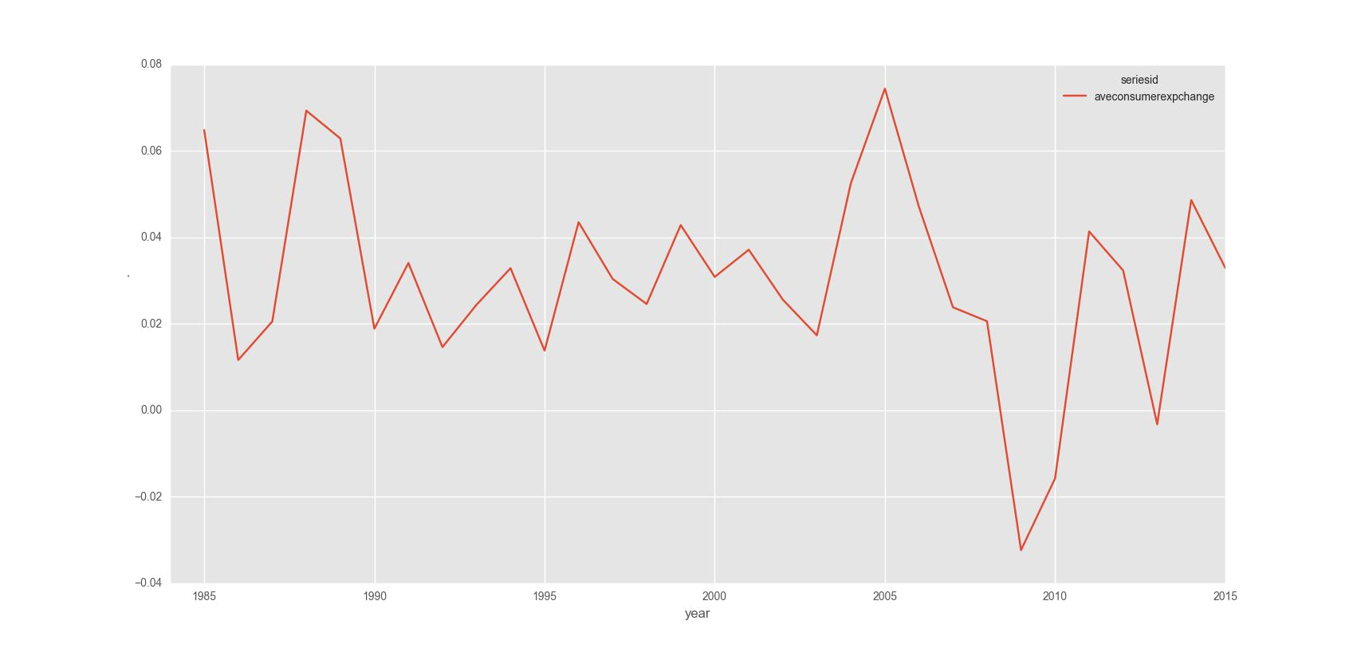

Fig 10.1 Average Consumer Expenditure % Change

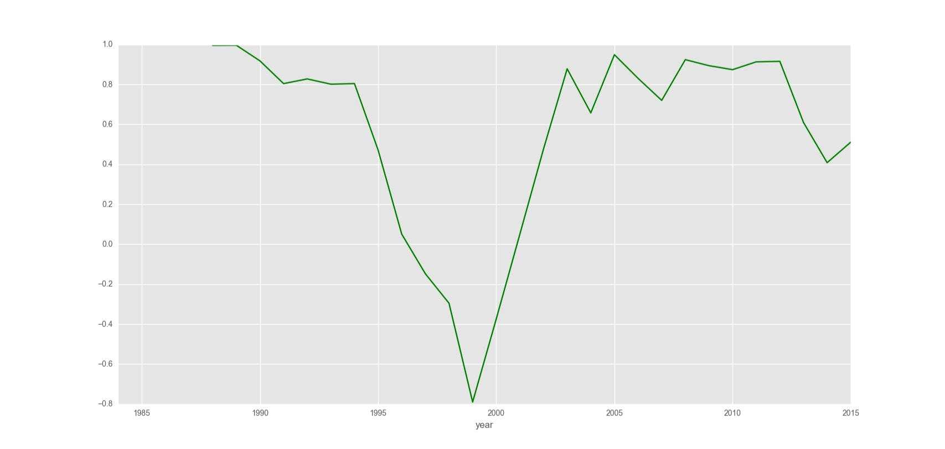

Fig 10.2 Correlation Housing vs Average consumer expenditure

28 | P a g e

Future prediction

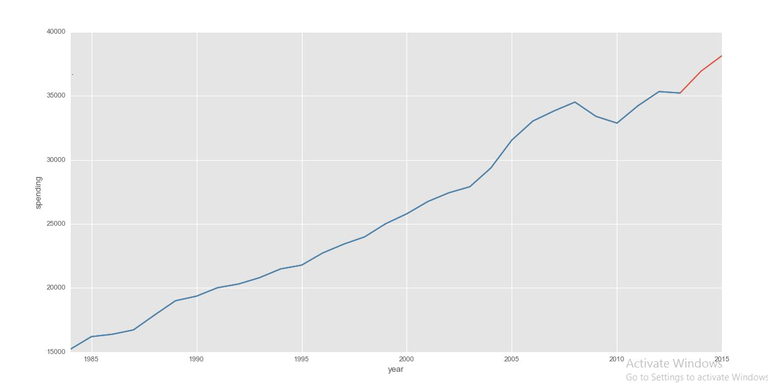

Fig 11. Average Consumer Expenditure Predicted

Accuracy=0.954383008599

(array([ 35847.27005143, 38856.39770397]), 0.95438300859867997, 2)

We selected linear regression as it gave the best accuracy above SVM and other models. As this is a timeseries, linear regression seemed to be the best possible model. We have predicted only future 3 year values as they gave the accuracy required.

#Applying Linear regression to predict future consumption
#select column to predict future values for

Predictionbase = 'averageconsumerexpense'

#replace any na values if present with a significantly low value that does not effect our final results

newbig.fillna(value=-99999, inplace=True)

#Only predicting 0.033% of future values
Output = int(math.ceil(0.033 * len(newbig)))

#shifting whole dataset up 1 and saving in new column label
newbig['label'] = newbig[Predictionbase].shift(-Output)

#converting dataframe to numpy array for training and testing we need data in array form
X = np.array(newbig.drop(['label'], 1))

#preprocessing step

X = preprocessing.scale(X)

X_lately = X[-Output:]

X = X[:-Output]

newbig.dropna(inplace=True)

y = np.array(newbig['label'])

#splitting into training and testing set whereby 20% of complete data is test set
trainingX, testingX, trainingY, testingY = cross_validation.train_test_split(X, y, test_size=0.2)

#Building a classifier
clf = LinearRegression(n_jobs=-1)
clf.fit(trainingX, trainingY)
accuracy = clf.score(testingX, testingY)
print(accuracy)

forecast_set = clf.predict(X_lately)
print(forecast_set, accuracy, Output)

newbig['Forecast'] = np.nan
'''newbig.index = pd.to_datetime(newbig.index, format='%Y')

last_date = newbig.iloc[-1].name
last_unix = time.mktime(last_date.timetuple())
one_year = 31536000
next_unix = last_unix + one_year

for i in forecast_set:
next_date = datetime.datetime.fromtimestamp(next_unix)
next_unix += 31536000
newbig.loc[next_date] = [np.nan for _ in range(len(newbig.columns)-1)]+[i]
'''
print(newbig.tail(10))

newbig['averageconsumerexpense'].plot()

newbig['Forecast'].plot()

plt.legend(loc=22)

plt.xlabel('year')

plt.ylabel('spending')

plt.show()

29 | P a g e

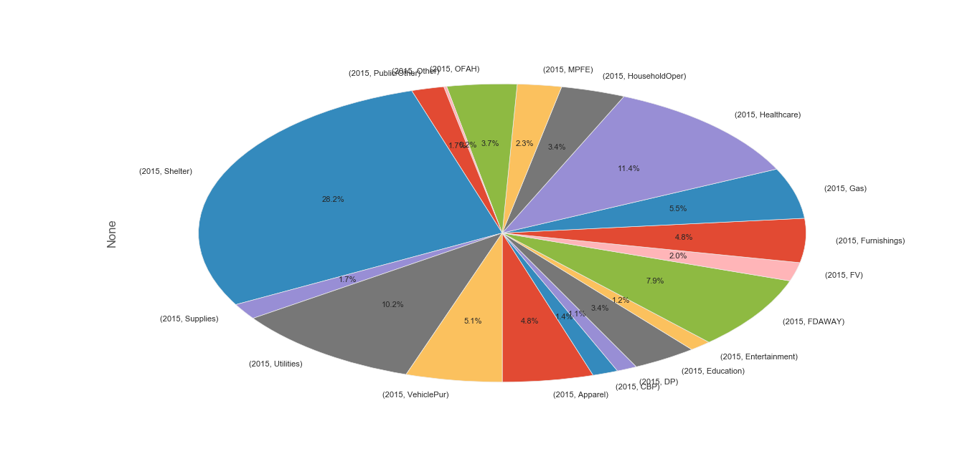

7. Conclusion:

7.1. Food:

It could be inferred that food is essential part of life. Hence the spending is comparatively high compared to other categories. The amount of money spent on Meat and other food can be used as a feature by retail companies and target the end user based on individual spending.

Personalized spending and goods could be suggested to consumers.

This data set helps the retail to manage inventory and stock the goods based on spending pattern in their area.

Retail segments could work organized and infer more analytical decisions that can leverage the business to new dimension

Market segment the buyers based on income , region and preference which can be used to introduce new service in the market .

30 | P a g e

7.2. Housing :

The spending on Housing comprises of following :

- Buying Apartment or shelter

- House furnishing goods such as furniture, electronic goods (Refrigerator, microwave oven)

- Complimentary services such as Electricity ,Water ,Repair

- Location of flat or house.
Comparing the insight from past 30 years data set of consumer spending in USA, the purchase power of owning a flat has increased to tremendously. This shows the interest of consumer or society.

Furniture :

On the other hand the money spent on furnishings is static and not exponential. With the growth of IOT technologies and electronic innovation, there is a possibility in upsurge of electronic goods that has in-built Wi-Fi connection adapters. While the spending on furniture is still expected to be static.

To drive the furniture market the flat promoters and builder can introduce innovative styles and customizable furniture’s based on consumer needs. One level above to seek an upsurge in furniture market would be furnished homes that has all the decorative and usable goods arrives at home prior to consumer.

Spending on Complimentary services (Water ,Gas, Electricity , Repairs & services)

Spending’s on complimentary goods is inevitable. With the Data age where IOT technologies gaining momentum, the usage of electricity will further increase dynamically. In this segment the Electricity providers can attract new consumers by

- Having an attractive plan that helps to optimize energy consumption

- Monitor and alert the consumer when energy usage increases threshold

Attracting more consumers with a fixed threshold will help electricity providers to scale the business to new level instead of having few high usage consumers.

Using the data-set containing the trend of consumer spending in electricity along with electronic innovations available , used by consumers , innovative services could be introduced in the market.

In the same way water , gas and Repairs and services market could be shaped in a better way using analytical solutions .A new complimentary service that could reflect in near future would be Wi-Fi.

31 | P a g e

Location of the Residence:

The location of residence impacts the services being offered. Same service need not be introduced in two different location. Based on location the tax differs, pollution increases at urban.

To regularize the interest of living in Urban , innovative solutions such as smart city could be introduced which helps to stay more in rural areas and enjoy the benefits of Urban . Government and partnered companies for “go green “ can find innovative solution in protecting rural setup and avoid deforestation.

Healthcare/Education/Entertainment/Apparel

The spending on Healthcare is prominent compared to other three. And it’s a fact that a good health could buy all the three. But the second highest is Apparel and not education .Education being the most important essential , Apparel and entertainment could be a complimentary that goes with healthcare and Education spending.

Hence Government and primary organization should take essential decision that leverage the growth of Education sector by promoting Apparel and Entertainment services.

Example :

Universities and Schools can promote the Apparel and Entertainment services based on merit ,events, festivals . Personalized offering to Entertainment and Apparel will strengthen the growth of Education sector where the society benefits with all the well beings.

Transport:

By inferring the trend from data set , it could be concluded that the spending on vehicles increases as long the Gasoline charges are at minimum. Price of Gasoline and Vehicle purchase is highly correlated. An increase in Gasoline promotes the growth of public transport or car pooling. Indirectly the Gasoline helps to protect the environment with less pollution.
APPENDIX_A(COMPLETE CODE)

# -*- coding: utf-8 -*-
import pandas as pd
import numpy as np
import math
from sklearn import preprocessing, cross_validation
from sklearn.linear_model import LinearRegression
import matplotlib.pyplot as plt
from matplotlib import style
import seaborn as sns
from tabulate import tabulate
import datetime
import time

style.use('ggplot')

#importing consumer expenditure data

dataframe1 = pd.read_csv('C:\Users\Dell\Desktop\qinal2.csv')

'''
First compare demographic categories age,income,race, and their correlation with spending on
different consumer items over the years and how the changes reflect spending power
'''

#comparing meat,poultry,fish and eggs spending
#replacing series_id's we need for this analysis
replaced1=dataframe1.replace(['CXUANIMALLB0102M ','CXUANIMALLB0106M ','CXUANIMALLB0402M ','CXUANIMALLB0403M ','CXUANIMALLB0404M ','CXUANIMALLB0405M ','CXUANIMALLB0406M ','CXUANIMALLB0407M ','CXUANIMALLB0806M ','CXUANIMALLB0809M ','CXUANIMALLB0902M ','CXUANIMALLB0905M ','CXUANIMALLB01002M '],['Lowincome','Highincome','age<25','age25-35','age35-45','age45-55','age55-65','age>65','urban','rural','white/asian','black','hispanic'])

Lowincomempfe=replaced1['seriesid']=="Lowincome"

Lowincomempfe2=replaced1['year']<2016

Lowincomempfe3=replaced1[Lowincomempfe & Lowincomempfe2]

Highincomempfe=replaced1['seriesid']=="Highincome"

Highincomempfe2=replaced1['year']<2016

Highincomempfe3=replaced1[Highincomempfe & Highincomempfe2]

#Highincomempfe3.corrwith(Lowincomempfe3,axis=0,drop=False)
#Highincomempfe3.merge(Lowincomempfe3, left_on='seriesid', right_on='year', how='outer')

mpfeincomeframe=[Lowincomempfe3,Highincomempfe3]

resultincomempfe=pd.concat(mpfeincomeframe)
#plt.plot(resultincomempfe['year'],resultincomempfe['value'])

#plt.bar(resultincomempfe['year'],resultincomempfe['value'])

#g=sns.FacetGrid(resultincomempfe,col='seriesid')
#plt.title('Comparison of meat,poultry,fish,eggs spending by income groups')
#g.map(sns.regplot,"year","value")
#plt.show()

agempfe=replaced1['seriesid']=="age<25"

agempfe2=replaced1['year']<2016

agempfe3=replaced1[agempfe & agempfe2]

age2mpfe=replaced1['seriesid']=="age25-35"

age2mpfe2=replaced1['year']<2016

age2mpfe3=replaced1[age2mpfe & age2mpfe2]

age3mpfe=replaced1['seriesid']=="age35-45"

age3mpfe2=replaced1['year']<2016

age3mpfe3=replaced1[age3mpfe & age3mpfe2]

age4mpfe=replaced1['seriesid']=="age35-45"

age4mpfe2=replaced1['year']<2016

age4mpfe3=replaced1[age4mpfe & age4mpfe2]

age5mpfe=replaced1['seriesid']=="age45-55"

age5mpfe2=replaced1['year']<2016

age5mpfe3=replaced1[age5mpfe & age5mpfe2]

age6mpfe=replaced1['seriesid']=="age55-65"

age6mpfe2=replaced1['year']<2016

age6mpfe3=replaced1[age6mpfe & age6mpfe2]

age7mpfe=replaced1['seriesid']=="age>65"

age7mpfe2=replaced1['year']<2016

age7mpfe3=replaced1[age7mpfe & age7mpfe2]

#age2mpfe3.corrwith(agempfe3,axis=0,drop=False)
#Highincomempfe3.merge(Lowincomempfe3, left_on='seriesid', right_on='year', how='outer')

mpfeageframe=[agempfe3,age2mpfe3,age3mpfe3,age4mpfe3,age5mpfe3,age6mpfe3,age7mpfe3]

resultagempfe=pd.concat(mpfeageframe)
#plt.plot(resultincomempfe['year'],resultincomempfe['value'])

'''g=sns.FacetGrid(resultagempfe,col='seriesid')
plt.title('Comparison of meat,poultry,fish,eggs spending by age groups')
g.map(sns.regplot,"year","value")
plt.show()
'''

areampfe=replaced1['seriesid']=="urban"
area2mpfe2=replaced1['year']<2016
area1mpfe=replaced1[areampfe & area2mpfe2]

areampfe2=replaced1['seriesid']=="rural"
area3mpfe2=replaced1['year']<2016
area1mpfe2=replaced1[areampfe2 & area3mpfe2]
mpfeareaframe=[area1mpfe2,area1mpfe]
resultareampfe=pd.concat(mpfeareaframe)

'''g=sns.FacetGrid(resultareampfe,col='seriesid')
plt.title('Comparison of meat,poultry,fish,eggs spending by area groups')
g.map(sns.regplot,"year","value")
plt.show()'''

c=replaced1['year']<2016
whitempfe=replaced1['seriesid']=="white/asian"
white2mpfe2=replaced1['year']<2016
white1mpfe=replaced1[whitempfe & white2mpfe2]

blackmpfe2=replaced1['seriesid']=="black"
black1mpfe2=replaced1[blackmpfe2 & c]

hispanicmpfe2=replaced1['seriesid']=="hispanic"
hispanic2mpfe2=replaced1['year']<2016
hispanic1mpfe2=replaced1[hispanicmpfe2 & hispanic2mpfe2]

mpferaceframe=[white1mpfe,black1mpfe2,hispanic1mpfe2]
resultracempfe=pd.concat(mpferaceframe)

#g=sns.FacetGrid(resultracempfe,col='seriesid')
#plt.title('Comparison of meat,poultry,fish,eggs spending by racial groups')
#g.map(sns.regplot,"year","value")
#plt.show()

mainframempfecom1=[Highincomempfe3,Lowincomempfe3,white1mpfe,black1mpfe2,area1mpfe2,area1mpfe]
finalmpfeframe1=pd.concat(mainframempfecom1)

#print(finalfood)
#finalmpfeframe.describe()

newmpfeframe1=finalmpfeframe1.pivot(index='year', columns='seriesid', values='value')

newmpfeframe1['totalpie']=newmpfeframe1.sum(axis=1)

#sframe=newmpfeframe1.stack()

# plot chart
#sframe.plot(kind='pie' , autopct='%1.1f%%', subplots=True)
#plt.title('Pie chart of MPFE for 2015')
#plt.xlabel('2015')

#plt.ylabel('spending')

#fig = plt.figure(figsize=(6,6), dpi=100)

#ax = plt.subplot(111)

#sframe.plot(kind='pie', ax=ax, autopct='%1.1f%%', startangle=270, fontsize=17, subplots=True)
#Taking a small subset of all food items and replacing their series_id with titles
#All consumer units value are taken here
#data2 has foods data

data2=dataframe1.replace(['CXUANIMALLB0101M ','CXUCERBAKRYLB0101M ','CXUDAIRYLB0101M ','CXUFOODAWAYLB0101M ','CXUFRUITVEGLB0101M ','CXUOTHRFOODLB0101M '],['MPFE','CBP','DP','FDAWAY','FV','OFAH'])
'''MPFE =meat,poultry,fish and eggs
CBP=cereals and bakery products
DP=Dairy Products
FDAWAY=Food consumed on outside trips
FV=Fruits and Vegetables
OFAH=Other Foods at home
'''
#datahousing has Shelter,Utilities,Household Operations,Supplies and Furnishings instead of all the categories in Housing as these were the most important
#for all consumer units

datahousing=dataframe1.replace(['CXUSHELTERLB0101M ','CXUUTILSLB0101M ','CXUHHOPERLB0101M ','CXUHKPGSUPPLB0101M ','CXUHHFURNSHLB0101M '],['Shelter','Utilities','HouseholdOper','Supplies','Furnishings'])

datahealthcare=dataframe1.replace(['CXUHEALTHLB0101M '],['Healthcare'])

#g=sns.FacetGrid(datahealthcare,col='seriesid')
#g.map(sns.regplot,"year","value")

dataapparel=dataframe1.replace(['CXUAPPARELLB0101M '],['Apparel'])

dataentertainment=dataframe1.replace(['CXUENTEROTHLB0101M '],['Entertainment'])

dataeducation=dataframe1.replace(['CXUEDUCATNLB0101M '],['Education'])

datatransport=dataframe1.replace(['CXUNEWCARSLB0101M ','CXUGASOILLB0101M ','CXUOTHVEHCLLB0101M ','CXUPUBTRANSLB0101M '],['VehiclePur','Gas','Other','Public/Other'])

#dataframe dataMPFE1 has the subcategories for consumer spending in meat,poultry,fish and eggs

dataMPFE1=dataframe1.replace(['CXUANIMALLB0201M ','CXUANIMALLB0401M ','CXUANIMALLB0601M ','CXUANIMALLB0801M ','CXUANIMALLB0901M ','CXUANIMALLB1101M ','CXUANIMALLB1301M '],['Income','Age','MaritalStatus','Housing','Race','Location','Education'])

print(datahousing)

#a holds year values<2016 for which the dataframe data2 has values for

a=data2['year']<2020

#Storing in new dataframes values for all the subcategories and merging with year<2016
Shelter1=datahousing['seriesid']=='Shelter'
Shelter2=datahousing[Shelter1 & a]

Utilities1=datahousing['seriesid']=='Utilities'
Utilities2=datahousing[Utilities1 & a]

Houseoperations1=datahousing['seriesid']=='HouseholdOper'
Houseoperations2=datahousing[Houseoperations1 & a]

Supplies1=datahousing['seriesid']=='Supplies'
Supplies2=datahousing[Supplies1 & a]

Furnishings1=datahousing['seriesid']=='Furnishings'
Furnishings2=datahousing[Furnishings1 & a]

#For health,education,entertainment,apparel

health1=datahealthcare['seriesid']=='Healthcare'
health2=datahealthcare[health1 & a]

education1=dataeducation['seriesid']=='Education'
education2=dataeducation[education1 & a]

entertainment1=dataentertainment['seriesid']=='Entertainment'
entertainment2=dataentertainment[entertainment1 & a]

apparel1=dataapparel['seriesid']=='Apparel'
apparel2=dataapparel[apparel1 & a]

mainframeheae=[health2,entertainment2,education2,apparel2]
finalheae=pd.concat(mainframeheae)

newheae=finalheae.pivot(index='year', columns='seriesid', values='value')
newheae['totalheae']=newheae.sum(axis=1)
newheae['totalchangeheae']=newheae['totalheae'].pct_change()
#For transport
Vehpur1=datatransport['seriesid']=='VehiclePur'
Vehpur2=datatransport[Vehpur1 & a]

Gas1=datatransport['seriesid']=='Gas'
Gas2=datatransport[Gas1 & a]

Other1=datatransport['seriesid']=='Other'
Other2=datatransport[Other1 & a]

Public1=datatransport['seriesid']=='Public/Other'
Public2=datatransport[Public1 & a]

#mainframehouse has all the dataframes for house category and finalhouse constitues all dataframes concatenated
mainframehouse=[Shelter2,Utilities2,Houseoperations2,Supplies2,Furnishings2]
finalhouse=pd.concat(mainframehouse)

#similarly mainframetrans and finaltrans for transport
mainframetrans=[Vehpur2,Gas2,Other2,Public2]
finaltrans=pd.concat(mainframetrans)

#newhouse dataframe has index replaced with year and columns represented as series_id's through pivot function

newhouse=finalhouse.pivot(index='year', columns='seriesid', values='value')
#newhouse[['Shelter','Utilities','HouseholdOper','Supplies','Furnishings']].plot(kind='line', use_index=True)

newhouse['totalhouse']=newhouse.sum(axis=1)
newhouse['totalchangehouse']=newhouse['totalhouse'].pct_change()
print(newhouse)

newtrans=finaltrans.pivot(index='year', columns='seriesid', values='value')
#newtrans[['VehiclePur','Gas','Other','Public/Other']].plot(kind='line', use_index=True)
newtrans['totaltrans']=newtrans.sum(axis=1)
newtrans['totalchangetrans']=newtrans['totaltrans'].pct_change()
#Similarly creating dataframes for each subcategory for MPFE and merging with 'a' to create new dataframes
incomempfe=dataMPFE1['seriesid']=='Income'
incomempfe2=dataMPFE1[incomempfe & a]

agempfe=dataMPFE1['seriesid']=='Age'
agempfe2=dataMPFE1[agempfe & a]

maritalmpfe=dataMPFE1['seriesid']=='MaritalStatus'
maritalmpfe2=dataMPFE1[maritalmpfe & a]

housingmpfe=dataMPFE1['seriesid']=='Housing'
housingmpfe2=dataMPFE1[housingmpfe & a]

racempfe=dataMPFE1['seriesid']=='Race'
racempfe2=dataMPFE1[racempfe & a]

locationmpfe=dataMPFE1['seriesid']=='Location'
locationmpfe2=dataMPFE1[locationmpfe & a]

educationmpfe=dataMPFE1['seriesid']=='Education'
educationmpfe2=dataMPFE1[educationmpfe & a]

mainframempfe=[incomempfe2,agempfe2,maritalmpfe2,housingmpfe2,racempfe2,locationmpfe2,educationmpfe2]
finalmpfe=pd.concat(mainframempfe)

print(finalmpfe.head(10))

#using seaborn library plotting mpfe subcategories spending over the 30years(all consumer units)
#to verify data is correct
#g=sns.FacetGrid(finalmpfe,col='seriesid')
#g.map(sns.regplot,"year","value")

#food data
mpfe1=data2['seriesid']=='MPFE'
mpfe2=data2[mpfe1 & a]

cbp=data2['seriesid']=='CBP'
cbp2=data2[cbp&a]

dp=data2['seriesid']=='DP'
dp2=data2[dp&a]

fdaway=data2['seriesid']=='FDAWAY'
fdaway2=data2[fdaway&a]

fv=data2['seriesid']=='FV'
fv2=data2[fv&a]

ofah=data2['seriesid']=='OFAH'
ofah2=data2[ofah&a]
mainframefood=[mpfe2,cbp2,dp2,fdaway2,fv2,ofah2]
finalfood=pd.concat(mainframefood)

#print(finalfood)
finalfood.describe()

newfoods=finalfood.pivot(index='year', columns='seriesid', values='value')
#print(newfoods)

#create a new column in newfoods dataframe called total and save the sum of all column values in that. This column represents total average consumer annual expenditure
#on food and what we will be using to predict future expenditure
newfoods['total']=newfoods.sum(axis=1)
newfoods['totalchangefoods']=newfoods['total'].pct_change()
#print(newfoods)

#Bigframe containing all the data and total of consumer expenditure for different types of food, housing, healthcare, transport, entertainment, apparel,education
Bigframe1=[Shelter2,Utilities2,Houseoperations2,Supplies2,Furnishings2,health2,entertainment2,education2,apparel2,Vehpur2,Gas2,Other2,Public2,mpfe2,cbp2,dp2,fdaway2,fv2,ofah2]
Bigframe2=pd.concat(Bigframe1)

newbig=Bigframe2.pivot(index='year', columns='seriesid', values='value')
newbig['averageconsumerexpense']=newbig.sum(axis=1)
newbig['aveconsumerexpchange']=newbig['averageconsumerexpense'].pct_change()
#plot averageconsumerexpense
newbig[['averageconsumerexpense']].plot(kind='line', use_index=True)

#correlation matrix heatmap for newfoods
'''corr = newfoods.corr()
corr = (corr)
sns.heatmap(corr,
xticklabels=corr.columns.values,
yticklabels=corr.columns.values)
sns.plt.title('Heatmap of Correlation Matrix')
corr
plt.show()'''

#Applying Linear regression to predict future consumption
#select column to predict future values for

Predictionbase = 'averageconsumerexpense'

#replace any na values if present with a significantly low value that does not effect our final results

newbig.fillna(value=-99999, inplace=True)

#Only predicting 0.033% of future values
Output = int(math.ceil(0.033 * len(newbig)))

#shifting whole dataset up 1 and saving in new column label
newbig['label'] = newbig[Predictionbase].shift(-Output)

#converting dataframe to numpy array for training and testing we need data in array form
X = np.array(newbig.drop(['label'], 1))

#preprocessing step

X = preprocessing.scale(X)

X_lately = X[-Output:]

X = X[:-Output]

newbig.dropna(inplace=True)

y = np.array(newbig['label'])

#splitting into training and testing set whereby 20% of complete data is test set
trainingX, testingX, trainingY, testingY = cross_validation.train_test_split(X, y, test_size=0.2)

#Building a classifier
clf = LinearRegression(n_jobs=-1)
clf.fit(trainingX, trainingY)
accuracy = clf.score(testingX, testingY)
print(accuracy)

forecast_set = clf.predict(X_lately)
print(forecast_set, accuracy, Output)

newbig['Forecast'] = np.nan
'''newbig.index = pd.to_datetime(newbig.index, format='%Y')

last_date = newbig.iloc[-1].name
last_unix = time.mktime(last_date.timetuple())
one_year = 31536000
next_unix = last_unix + one_year

for i in forecast_set:
next_date = datetime.datetime.fromtimestamp(next_unix)
next_unix += 31536000
newbig.loc[next_date] = [np.nan for _ in range(len(newbig.columns)-1)]+[i]
'''
print(newbig.tail(10))

newbig['averageconsumerexpense'].plot()

newbig['Forecast'].plot()

plt.legend(loc=22)

plt.xlabel('year')

plt.ylabel('spending')

plt.show()

